Year 11 Homework Spanish
Name
Cycle | 1 | Week | 1
Hand in Date

You should spend time on Quizlet practicing this week’s vocabulary.
It is important to listen to the vocabulary as well as look at it. Practice saying it out loud.

Week 1 – Education self-test
school subject
hard / easy
bullying
school
language x 1
language x 2
pupil
theme, subject
behaviour
mark, grade
head teacher
sports field
a rule x 1
a rule x 2
success
level
test, proof
school trip

Conjugate ESTUDIAR in the Present Tense:
I study _______________________________
You study (s) __________________________
He / she studies ________________________
We study _____________________________
You study (pl) _________________________
They study ____________________________

Strategy: Role Play
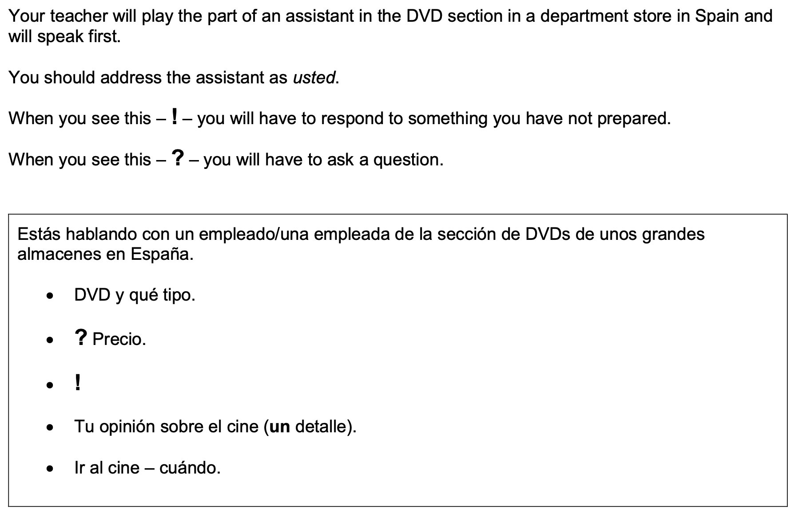
¿Para quién es el DVD?
- Highlight the context. Where are you? Who are you talking to?

______________________________________________________________________________

- Translate the bullets into English (do this above).

- Draft a response in Spanish using FULL sentences each time.

- ____________________________________________________________________________________________________________________________________________________________
- ______________________________________________________________________________
______________________________________________________________________________
- ____________________________________________________________________________________________________________________________________________________________
- ____________________________________________________________________________________________________________________________________________________________
- ______________________________________________________________________________
_____________________________________________________________________________________

