Year 11 Homework Computer Science
Name
Cycle | 1 | Week | 1
Hand in Date

What is the definition of the word Variable? ………………………………………………………………………………………………….………………………………………………...……………...…………
What is the main difference between lossy and lossless compression? …………………………………………………………………………………………………….………………………………………………..………………………
Programming Writing  Please write a function called Double which takes 1 parameter, doubles it and then returns the value  def _________ (_________):  return _____________  Programming Reading  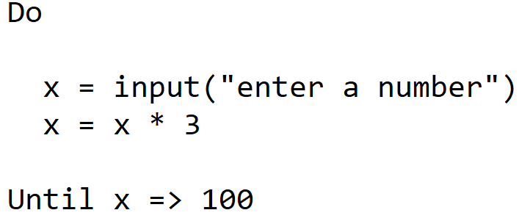  What number would have to be entered here to stop this iteration from running?  _________ | Programming Reading  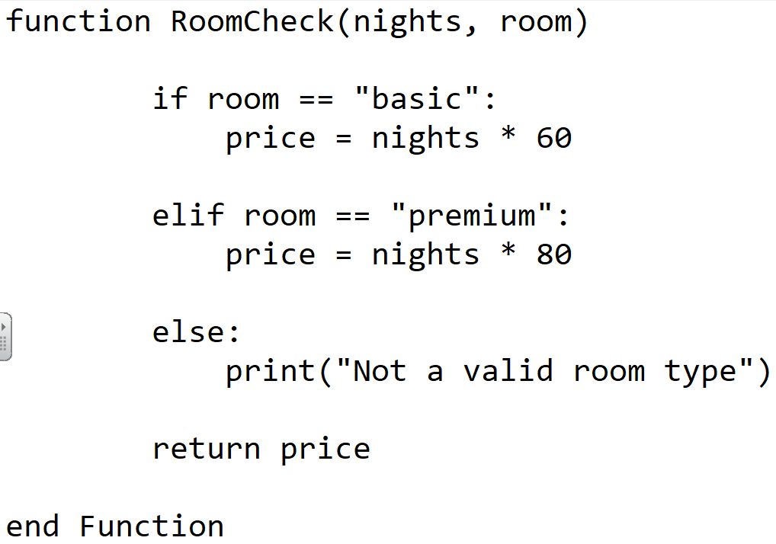  How many parameters does this function have? ______  What would be returned from this:  roomCheck(3, “basic”) ________  Does this code contain?  Technique Tick  Selection  Sequence  Iteration
