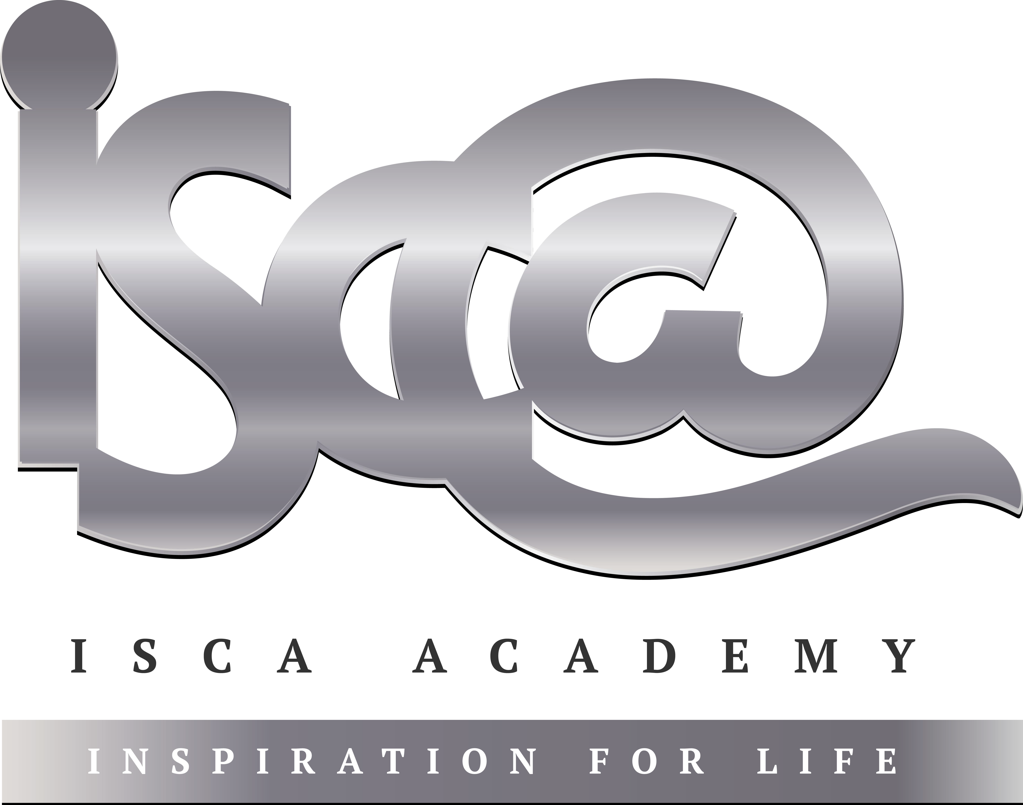
Year 11 Homework
Subject | History
Cycle | 1 | Week | 1
Hand in Date

Step 1: Complete the Week 1 Seneca quiz (class code: cx76l0q9h8) – If you don’t yet have a login please speak to your History teacher. Tick the box below to show that you’ve done it and enter the time you’ve spent on this week’s quiz.

Seneca complete Time spent:____________________

Step 2: Complete the tasks below:

- Label what you can see happening in the source below.
- Finish the sentence: ‘The source tells me that the Night of the Long Knives was important because______
____________________________________________________________________________________________________________________________________________________________________________________________________________________________________________________________________________________
__________________________________________________________________________________________________________________________________________

