Friday 7th January 2022

Dear Parents/Guardians,

Reference: Autumn Term Report 2021

We are pleased to provide your child’s autumn term report. Following feedback from families, we are delighted to launch our new reporting system using the platform Go4Schools. This will allow you to be able to access ‘live’ data on your child whenever you wish. We have created a reporting tab http://links.iscaexeter.co.uk/go4schools-new-user on our website which will give you direct access to your child’s information. It also contains a help guide alongside details of who to contact should you have trouble accessing the information. We would like to know what you think about this new format and would welcome your feedback by accessing the linked questionnaire: https://links.iscaexeter.co.uk/report-format-feedback .

The Autumn Term Report 2021, will provide you with a full update on the progress, effort and behaviour for your child in each subject, as well as their attendance and the number of merits / demerits they have accrued thus far this academic year. You will receive one of these reports each term.

To provide you with greater clarity about what the report means and how to interpret it, please see below for further details:

What does predicted grade and progress to target mean?

Predicted grade – this is the grade your child’s teacher thinks they are likely to achieve if they continue to work as they are currently. It is probable that this will be slightly higher than their performance in their November mock examination, given there is just under a term and a half’s teaching still to go.

Your child sat a full series of mock examinations at the end of November 2021. Their teacher has used the information from these examinations alongside their classwork and homework to report on their progress.

Progress to target means how ‘close’ a student is to their target grade

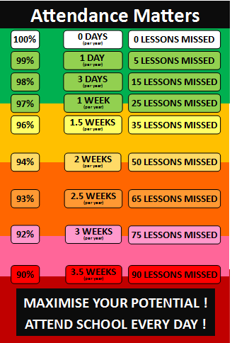
- Above target – one or more grades above their target grade
- On target – within a grade of their target grade
- Below target – within two grades of their target grade
- Well below target – more than two grades below their target grade

Your child’s target grade is generated using a national system based on performance in their Key Stage 2 SATs assessments which they sat in Year 6 at primary school.

Attendance

It is vitally important that your child attends school every day so that they can learn and achieve. We acknowledge that on occasions students will be unwell and that COVID has made maintaining excellent attendance a real challenge. During ‘non-COVID’ times, we expect all students to have 96% attendance as a minimum. If your child’s attendance is below this and it is not COVID related, please do work with your child’s tutor and Head of Year to discuss how we can support you to ensure their attendance at school improves. Each term we reward students with excellent attendance as well as though whose attendance is improving.

You might be interested in the graphic on the right which shows just how much learning time can be lost through poor attendance.

What do the ‘behaviour’ and ‘effort’ comments mean?

Please refer to the explanation given below your child’s report which explains each category in full.

If your child has received a ‘Requires Improvement’ or ‘Inadequate’ comment, please ensure you talk to your child’s subject teacher and attend parents’ evening to discuss in further detail.

What is a Merit?

These are awarded for good behaviour. For example each day students receive one merit mark for being on time, one for being fully equipped and one for having completed their homework. We also reward students who reflect our school values of: Inclusion, responsibility, equality, ambition, collaboration and honesty.

What is a Demerit?

These would be applied in the following circumstances: for example, if a student hasn’t completed their homework, is missing an item of equipment or uniform, is referred to the RESET room.

If you have any further questions regarding this report, please do not hesitate to contact your child’s tutor.

Yours sincerely,

Miss A Mills
Senior Deputy Headteacher
Email: amills@iscaexeter.co.uk

