Y11 Cycle 1 Week 3 Combined Science Homework: Extended writing questions (Foundation)
Q1.
(a) Complete the sentence by putting a cross ( ) in the box next to your answer.
Sperm cells and egg cells contain sex chromosomes.
Egg cells contain
(1)
A one X chromosome
B one Y chromosome
C two X chromosomes
D two Y chromosomes

(b) (i) Complete the Punnett square to show how the sex of a child is inherited.
(2)
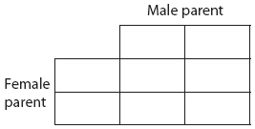

(ii) Calculate the percentage chance that a child will be female.
(1)
..............................................................................................................................................

(c) The diagram shows the level of two hormones involved in the menstrual cycle and the thickness of the uterus lining.

Using the information in the diagram and your own knowledge, describe the stages of the menstrual cycle.
(6)
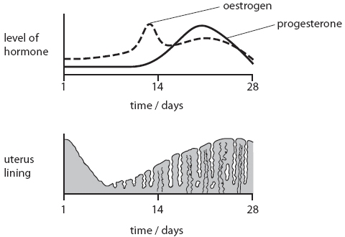

..............................................................................................................................................
If you’re stuck try searching for this video on youtube ‘GCSE Biology The Menstrual Cycle (Foundation) Edexcel 9-1’

Hint: Look at the graphs on the previous page. Say what is happening to the hormone and then what is happening to the lining of the uterus

On day one of the menstrual cycle the …..
Key words
Menstruation Uterus lining
Ovulation Ovum
Maintained Thickened
Increases Decreases

..............................................................................................................................................
..............................................................................................................................................
..............................................................................................................................................
..............................................................................................................................................
..............................................................................................................................................
..............................................................................................................................................
..............................................................................................................................................
..............................................................................................................................................
..............................................................................................................................................
..............................................................................................................................................
..............................................................................................................................................
..............................................................................................................................................
..............................................................................................................................................
..............................................................................................................................................
..............................................................................................................................................
..............................................................................................................................................
..............................................................................................................................................
..............................................................................................................................................
..............................................................................................................................................
..............................................................................................................................................
..............................................................................................................................................

(d) Explain what happens to the uterus lining if a woman becomes pregnant.
(2)
..............................................................................................................................................
..............................................................................................................................................
..............................................................................................................................................
..............................................................................................................................................
(Total for Question = 12 marks)

Mark scheme
Q1.
 | Answer | Acceptable answers | Mark
(a) | A one X chromosome |  | (1)
(b)(i) | correct gametes (1)  correct offspring (1) 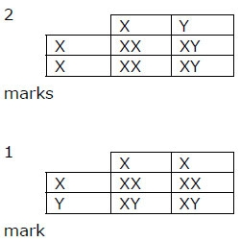 | 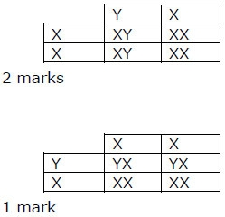Please note: XY or YX are both correct. The letters can be written in either order. letters can be upper or lower case. female offspring must be shown as XX and not a single large X ecf – If the gametes are reversed then the Punnett square must be completed correctly and show the valid offspring genotypes, two XX and two XY. | (2)
(b)(ii) | 50(%) |  | (1)

 |  | Indicative Content | Mark
QWC | *(c) | A description including some of the following points: Uterus lining  • menstruation occurs between day 1 and 5/6  • this is when the lining of the uterus is shed  • the lining of the uterus is then built back up  • at day 14 ovulation occurs  • the lining of the uterus is maintained/thickened  • to prepare for a fertilised ovum  • if the ovum is not fertilised  • the cycle starts againHormones involved  • oestrogen levels are low in the early part of the cycle  • oestrogen levels increase prior to ovulation  • after ovulation oestrogen levels drop  • the oestrogen levels remain higher than before ovulation  • from day 1 – 14 progesterone levels are low  • progesterone levels rise after ovulation  • hormone levels drop if the ovum is not fertilised | (6)
Level | 0 | No rewardable content
1 | 1 - 2 | • a limited description of the changes in the lining of the uterus wall OR the hormone levels over the 28 day period  • the answer communicates ideas using simple language and uses limited scientific terminology  • spelling, punctuation and grammar are used with limited accuracy
2 | 3 - 4 | • a simple description of the changes in the lining of the uterus wall AND a mention of the role of least one of the hormones  • the answer communicates ideas showing some evidence of clarity and organisation and uses scientific terminology appropriately  • spelling, punctuation and grammar are used with some accuracy
3 | 5 - 6 | • a detailed description of the changes in the lining of the uterus wall AND the role of hormones related to ovulation or uterus lining thickness  • the answer communicates ideas clearly and coherently uses a range of scientific terminology accurately  • spelling, punctuation and grammar are used with few errors

 | Answer | Acceptable answers | Mark
(d) | An explanation linking two of the following  • uterus wall maintained/thickened (1)  • progesterone levels remain high/increase(1) | accept to provide a place for the fertilised egg/embryo/fetus to develop | (2)

