Y11 Cycle 1 Week 3 Combined Science Homework: Extended writing questions (Separate)
Q1.
The diagram shows the body's response to dehydration.
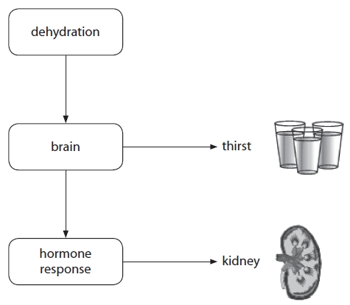
(a) Use the diagram to help explain the body's hormonal response to dehydration.
(4)
.............................................................................................................................................
.............................................................................................................................................
.............................................................................................................................................
.............................................................................................................................................
.............................................................................................................................................
.............................................................................................................................................
.............................................................................................................................................
.............................................................................................................................................
(b) The menstrual cycle is also controlled by hormones including progesterone.
(i) Complete the sentence by putting a cross () in the box next to your answer.
Progesterone is produced by the
(1)
A corpus luteum
B glomerulus
C hypothalamus
D pituitary gland
(ii) Describe the effect of high levels of progesterone on the uterus lining during pregnancy.
(1)
.............................................................................................................................................
.............................................................................................................................................
*(b) (iii) Explain how the menstrual cycle is controlled by hormones and negative feedback.
(6)
.............................................................................................................................................
.............................................................................................................................................
.............................................................................................................................................
.............................................................................................................................................
.............................................................................................................................................
.............................................................................................................................................
.............................................................................................................................................
.............................................................................................................................................
.............................................................................................................................................
.............................................................................................................................................
.............................................................................................................................................
.............................................................................................................................................
.............................................................................................................................................
.............................................................................................................................................
.............................................................................................................................................
.............................................................................................................................................
.............................................................................................................................................
.............................................................................................................................................

(Total for question = 12 marks)

