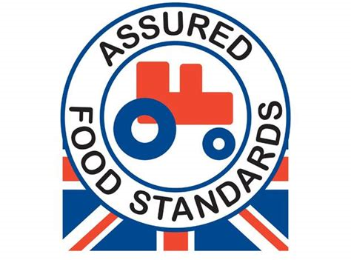

Week 1 wc 28/10/19, 18/11/19, 9/12/19, 30/12/19, 17/2/20, 9/3/20, 30/3/20

Monday | Tuesday | Wednesday | Thursday | Friday
Chicken Rogan Josh & Turmeric Rice | Glamorgan Sausage | Roast Beef, Yorkshire Pudding & gravy | Southern Baked Chicken Burger | Baked  Breaded  Pollack & Chips
Sweet Potato & Chick Pea Curry & Turmeric Rice | Vegetarian Sausage Roll | Roast Quorn fillet and gravy | Halloumi Burger | Quorn & Roasted Cherry Tomato Pasta Bake
Bombay Potatoes & Mango Chutney | Oven Baked Sweet Potato Wedge & Coleslaw | Roast Potatoes, Broccoli & Roasted Carrots | Roasted Corn on the Cob & American Potato Salad | Garden Peas, Baked Beans, Mushy Peas & Chip Shop Sides
Baked Potato with a choice of Fillings | Baked Potato with a choice of Fillings | Baked Potato with a choice of Fillings | Baked Potato with a choice of Fillings | Baked Potato with a choice of Fillings
Garden salad | Garden salad | Garden salad | Garden salad | Garden salad
Lemon Cheesecake | Chocolate Beetroot Cake | Oaty Peach Crumble & Custard | Carrot & Apple Muffin with Custard | Chocolate & Vanilla Custard Pots
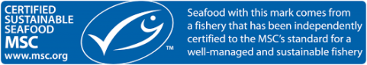

Week 2 wc 4/11/19, 25/11/19, 16/12/19, 3/2/20, 24/2/20, 16/3/20

Monday | Tuesday | Wednesday | Thursday | Friday
Homemade Beef Meatballs in Tomato Sauce | Caribbean Veggie Sausage Pepper Pot | Roast Gammon & Gravy | Reggae Reggae Chicken Tortilla | Baked Pollack or Baked Salmon Steak
Italian Bake Gnocchi | Ricotta, Spinach & Lentil Lasagne | Roast Quorn Fillet or Macaroni Cheese | Reggae Reggae Three Bean Chilli | Spinach & Mint Frittata
Wholemeal Pasta, Coleslaw, Tomato, Red Onion & Carrot Salad | Sweet Potato Wedges, Sauté Leeks & Glazed Carrots | Roasted Potatoes, Savoy Cabbage & Glazed Carrots | Jamaican Rice & Peas,Spicy Sweetcorn & Reggae Reggae Slaw | Cihips, Garden Peas, Baked Beans, Mushy Peas & Chip Shop Sides
Baked Potato with a choice of Fillings | Baked Potato with a choice of Fillings | Baked Potato with a choice of Fillings | Baked Potato with a choice of Fillings | Baked Potato with a choice of Fillings
Garden salad | Garden salad | Garden salad | Garden salad | Garden salad
Lemon Curd Meringue Slice | Honey & Mint Spiced Oranges | Chocolate Sponge & Chocolate Custard | Caramelized Pineapple Chunks | Fruity Feast Flapjack

Week 3 wc 11/11/19, 2/12/19, 23/12/19, 10/2/20, 2/3/20, 23/3/20

Monday | Tuesday | Wednesday | Thursday | Friday
Pork Sausage | Vegetable Bean Champ Cottage Pie | Roast Turkey, Sage & Onion Stuffing with Gravy | Chilli Beef Burrito Cone | Baked Pollack
Quorn Sausage | Courgette Spaghetti, Tomato & Butterbeans | Roast Quorn Fillet | Vegetable Chilli Burrito Cone | Vegan Nuggets
Creamy Mashed Potato, Peas and Onion Gravy | Garden Peas & Sweetcorn | Roast Potatoes, Savoy Cabbage & Carrots | Braised Wholemeal Rice, Roasted Squash & Peppers | Chips, Garden Peas, Baked Beans, Mushy Peas & Chip Shop Sides
Baked Potato with a choice of Fillings | Baked Potato with a choice of Fillings | Baked Potato with a choice of Filling | Baked Potato with a choice of Fillings | Baked Potato with a choice of Fillings
Garden salad | Garden salad | Garden salad | Garden salad | Garden salad
Rhubarb Crumble & Custard | Mindful Berry Mousse | Jam & Coconut Sponge with Custard | Mandarin Orange Jelly | Chocolate Cornflake Crunch

