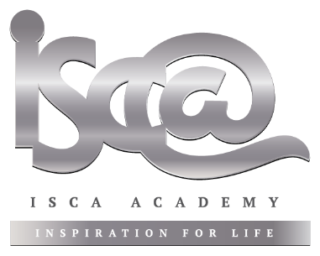

20th March 2020

Dear Parents/Guardians,

Information for Parents - Year 8 Options

Please see below and on our website some information about the Year 8 options process, in lieu of our options information evening, which had to be cancelled earlier this week.

I would encourage you and your child to consider the information carefully before deciding the subjects which they wish to study up to GCSE level from September 2020. Your guidance will be important in helping your child to reflect on the implications of their choices for potential future career directions and how best to balance this with their individual interests and talents. Our staff will, of course, also be on hand if you require additional information or advice to make these decisions; please do not hesitate to email your child’s subject teachers directly.

Students will have the opportunity to choose four subjects to study from Year 9 through to the end of Year 11. These subjects will go alongside the core curriculum of English, Maths, Science, RE, PE and PSHE. We will need you to complete the form (see the link below) to indicate your child’s choices, and return this to us by Monday 20th April 2020. It is based on students’ option choices that we will plan the timetable and staffing for September 2020 and it is important, therefore, that all forms reach us by the deadline. We have also asked that you chose a reserve option choice because there will be restrictions on the group sizes and the number of groups that we can have which may mean that you will need the reserve choice.

Option choice form: https://forms.office.com/Pages/ResponsePage.aspx?id=7gN1hFwzdU2Rm42EYq_QXYOlCm5tEOZDl7iqxO1wGclUM1JPQkVSR0RLVUhOTkk4MktaMTFBTDRRVi4u

On our school website are two presentations which, we hope, will be helpful in better understanding the process:
- Presentation from Mrs Goode, Assistant Headteacher with responsibility for options;
- Presentation planned by Kerry Balchin, a representative from Exeter College.
We have also prepared short booklets with detailed information about each option subject, which can be viewed or downloaded from our school website, or alternatively can be collected in person from the school reception. Bearing in mind the imperative to reduce person to person contact at present, we would appreciate it if only those parents who cannot access the website could opt to collect from school. Thank you for your co-operation.

You may also find the following links useful:
https://icould.com/article/choosing-your-gcse-options/ Take the Buzz quiz!
https://university.which.co.uk/advice/gcse-choices-university/how-important-are-gcse-choices-when-it-comes-to-university

As ever, please do not hesitate to be in touch if we can be of any assistance.

Yours sincerely,

Miss Aimee Mitchell
Headteacher

