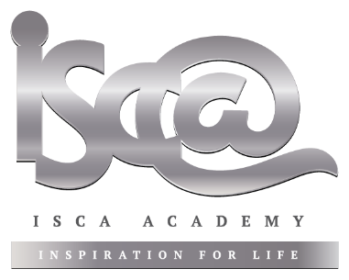
16th November 2020
Dear Parents / Carers,
Re: Year 11 Update
I’d like to take this opportunity to update you with some key dates for your diary and to make you aware of some of the supportive measures we are putting in place for your son / daughter.
We have planned two mock examination series, the first of which will begin on Monday 23rd of November and will run for two full weeks. The mock examinations will allow us to identify your child’s strengths and areas for development, providing vital information which we can then use to support them in the coming months with their learning. On Friday 13th November every student was given their ‘statement of entry’ (this tells them the examinations they will be sitting) and an Examinations’ Booklet. This is a ‘go to’ document for all key information relating to the examinations. Please can I ask that you check your son / daughter has read this and is fully prepared for what to bring, what to expect and how to behave during the examinations. We have also updated our website with this information: https://iscaexeter.co.uk/school-life/exams/.
All year 11 students have already sat examinations / assessments in English, Mathematics and Science so far this term and we have used this information to plan a number of interventions to support your child:
- We have rearranged the tutor groups so that students receive valuable additional teaching time in English, Mathematics or Science in four of the five daily tutor sessions. Each of these sessions will operate like a timetabled lesson and focuses on providing students with very clear and targeted feedback to tackle the areas they found problematic in the examinations they have just sat.
- We will be running a ‘period 6’ three days a week for selected students to receive additional teaching time in English, Mathematics and Science. We will be inviting students on a Tuesday for Mathematics, a Wednesday for English and a Thursday for Science. If your son / daughter has been selected, you will receive an individual letter from us containing all of the details. This is a very specific intervention, targeted to those who need it most, which we know makes a huge difference to those who attend.
- We will also be setting up some individual and small group interventions to ensure we are supporting students to close their gaps in knowledge and skills. Again, we will be inviting specific students and you will receive an individual letter from us if your son / daughter has been selected.
If your son / daughter is in receipt of Exams Access Arrangements, you will receive a letter from our SENDCo detailing why these are in pace and what specifically in terms of support, they offer your child. We recognise that this is a very stressful time for our students and we have a number of mechanisms in place in school to support students’ mental health and wellbeing, details of which are on our website and available in school. We have also detailed a raft of external support which can be accessed in the above link.
Please can I take the opportunity to thank you for your ongoing support, it is very much appreciated.
Yours faithfully,

Anna Mills
Senior Deputy Headtecaher

