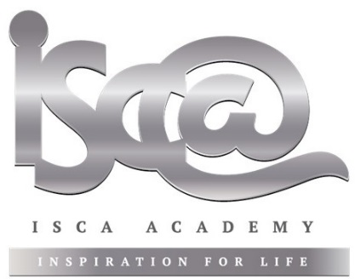

20 April 2021

Dear Parent/Carer

JURASSIC COAST CHALLENGE 2021

Your child has expressed an initial interest in participating in a team walking challenge along the Jurassic Coast on Friday 2nd July 2021.

This will involve a training walk on Friday 28^{h} May 2021 (Year 8 walkers only), and then the event itself in July, which will be a long day with an early start. The cost of this optional activity will be £18. Your child will need to be suitably equipped to take part – essential for day walks are:

- Waterproof coat with hood (not “showerproof” or “water resistant”)
- Waterproof trousers
- Stout footwear (boots ideal, but not wellies)
- Warm hat / sun hat if hot
- Gloves if cold
- Spare warm clothes
- Water bottle
- Packed lunch / snack food
- Rucksack with thick plastic liner to keep contents dry

Students will need to have completed the Parental Consent Form and medical form linked below in order to take part. Students will be transported in minibuses or a coach, starting from Isca Academy at 0900 for training on 28th May and 0500 (not a misprint!) for the event itself on 2nd July.

We are organising this event for Years 8-10 students at Isca only this year as we are still trying to avoid mixing school populations for obvious reasons. The event will be a challenge not a race. Some points to note:

- FRIDAY 2nd JULY 2021 is the event date
- Lyme Regis is the start point at 0700 for all teams at the Cobb car park
- Teams will declare themselves as Bronze, Silver or Gold a week before the start.
- Finish points will be at Branscombe (Bronze – 10 miles), Sidmouth (Silver – 16.2 miles) and Budleigh Salterton (Gold – 23 miles)
- “Crash” times at Branscombe and Sidmouth will determine whether teams continue.
- Regular checkpoints are at 3-5km intervals
- It will be a challenge not a race – there will be JCC medals for all finishers.
- Teams will be 4-6 walkers in number, with any combination of genders and year groups.
- Teams can choose to raise money for charity – our preferred option is Children’s Hospice SW.

Students are advised to return forms as soon as possible as we are likely to be oversubscribed for this event. We will allocate training places on a first come first served basis. Max 50xYear 8, 20xYear 9, 20xYear 10. (N.B. Years 9/10 will have to have some previous team walking experience e.g. Ten Tors, D of E expeditions, or Exe Valley Challenge)

It will be physically challenging, covering a distance of 10-23 miles on the tough hills of the magnificent Jurassic Coast. On the day of the event in July, teams will have to complete the course unassisted.

For pupils to apply to take part please pay the £5 deposit as soon as possible and complete the Parental Consent Form using the following link - Parental Consent Jurassic Coast Challenge 2021 – the remaining balance of £13 will need to be paid by Friday 7 May 2021. Payment can be made using the SCOPAY app or logging onto www.scopay.com.

Yours sincerely,

John Miller

