Combined science HT homework Name ………………………………..

Q1. Some pieces of calcium carbonate were added to dilute hydrochloric acid in a conical flask and the volume of carbon dioxide produced was measured. Complete the diagram in Figure 5 to show the apparatus to collect the gas produced and measure its volume.
(2)
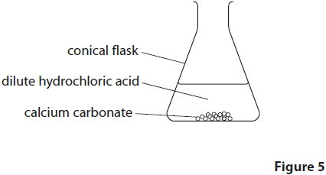

(Total for question = 2 marks)
Q2. The calcium carbonate powder produced 90 cm³ of carbon dioxide in five minutes.
Calculate the average rate of reaction in cm³s^{–1}.
(3)
.............................................................................................................................................
.............................................................................................................................................
.............................................................................................................................................
.............................................................................................................................................
average rate of reaction = ........................................................... cm³s^{–1}

Q3. During any reaction, reactants are used up and the rate of reaction decreases.
Explain, in terms of particles, why the rate of reaction decreases.
(2)
.............................................................................................................................................
.............................................................................................................................................
.............................................................................................................................................
.............................................................................................................................................

(Total for question = 2 marks)
Q4. Explain, in terms of particles, why the rate of reaction increased when the
temperature was increased.
(3)
.............................................................................................................................................
.............................................................................................................................................
.............................................................................................................................................
.............................................................................................................................................
.............................................................................................................................................
.............................................................................................................................................

(Total for question = 3 marks)

Q5. Two gases, X and Y, react to give a gaseous product Z.
The reaction is carried out under two different sets of conditions in experiments 1 and 2 as shown in Figure 9.
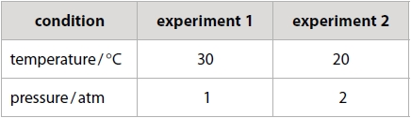
Figure 9
Explain why it is not possible to predict what the rate of Experiment 2 will be compared with Experiment 1.
(3)
.............................................................................................................................................
.............................................................................................................................................
.............................................................................................................................................
.............................................................................................................................................
.............................................................................................................................................
.............................................................................................................................................

(Total for question = 3 marks)

