Tuesday 26th April 2022
Exe Valley Challenge Team Managers Brief
Dear Team Managers,
EVC is organised by Isca Academy principally to provide young people with the chance to test themselves as individuals and to develop their ability to work as a team. During the actual event, we wish all teams (except Mini’s) to enjoy this experience with minimum adult support and no direct supervision on the course.
Safety
- The wellbeing of all participants from the time each team is called forward at the start, until their return to Isca Academy is our primary concern. Participants who don’t complete the course and drop out will be collected by Isca Academy staff, returned to school and handed over to the Team Managers.
- Only 1 member of a team may drop out – teams of less than 3 will not be allowed to continue.
- The marshals at the checkpoint will take reasonable steps to ensure participants are fit to continue with the event.
- We are aware of issues relating to child protection and all of our marshals are briefed to treat with suspicion any approach to a participant by person(s) unknown to them.
- Basic first aid is available at the checkpoints and Devon Emergency Medical Services provide additional First Aid cover during the event.
- In addition to our army of volunteers at checkpoints and other locations along the route, Police Cadets from Devon and Cornwall will provide additional support at Countess Wear and St David’s bridges’.
Team Managers
Team Managers should;
- Ensure they have all the necessary consent forms from parents/carers.
- Be aware of any medical issues which might affect participants during the challenge e.g. asthma, hay fever etc.
- Ensure that all participants are adequately prepared, trained and equipped for the event
- Completed and returned the booking form, and payed the fees as required.
- Ensure that parents/carers receive a copy of ‘Parent Info Pack’ prior to the event, it contains information that is relevant to the safety of the participants and helps reduce any misunderstanding regarding areas of responsibility during the event.
We appreciate your commitment in entering teams in to the EVC and we very are grateful for all your efforts.
The Route: The route starts and finishes at Isca Academy and follows a 10-mile (senior), 7-mile (junior) or 5-mile (mini’s) course around the Riverside Valley Park, Pepper Pots Playing Fields and the Quay, reporting to check points along the way. The Route will be marshalled by clearly identifiable, DBS checked volunteers, supported by the Police Cadets and Isca Academy staff, many of who are qualified first aiders. Copies of the route can be found on the EVC section of the school website. The sketch map below shows the 10-mile Senior route.
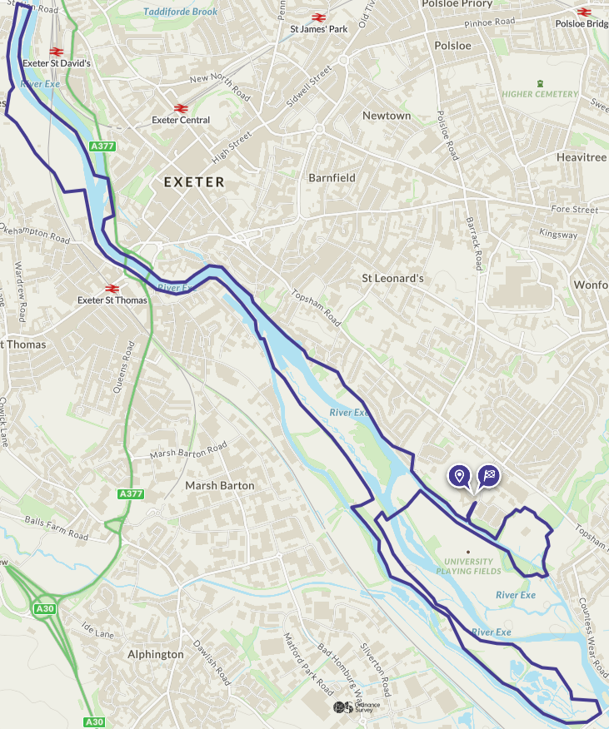
Teams: must start with four pupils. This can be in any combination and the category in which they compete will be determined by the eldest member of the group. The categories are:
Mini’s (year 2/3) mixed
Junior (year 4/5) girls/boys/mixed
Senior (year 6/7) girls/boys/mixed
For event planning purposes we require the approximate number of teams you wish to enter to be submitted on the EVC Booking Form 2022 and we will then start the registration process. This form must be submitted by Friday 27th May 2022.
You must complete and return the EVC Final Team Details Form 2022 Form by Friday 17th June 2022.
Fees: There is an entry fee of £20 per team. All team fees must be paid by Friday 17th June. Fees are non-refundable. Fees should be paid by cheque made payable to ‘Isca’ or may be paid online, details will be sent upon receipt of the initial entry form.
Training support: Isca Academy are able to provide some support for EVC route training and in addition, teams are welcome to piggyback onto Isca Academy training days (details available upon request). Please contact me as soon as possible for details or to discuss other requests for help, such as school assemblies (presentation/talk) regarding the event.
Shadowing: One of the aims of this event is to encourage independent team working, however we recognise for a group to have a successful outcome they may require older Isca Academy students to accompany them (with the exception of Year 2 & 3, parents/carers are not encouraged to accompany their child unless there are special circumstances or requirements). Team managers can apply to have teams from Years 4, 5 and 6 shadowed. Whilst we appreciate there are often last-minute changes to teams, for organisation purposes it would be helpful if you could inform me by 21th June 2022.
Equipment: Teams will be required to carry certain equipment with them such as a waterproof coat, a personal first aid kit, snacks and drinks and be dressed appropriately. Teams will be checked as they leave so please check that your team is correctly equipped to save time. See EVC Kit List 2022.
Questions: If you have any concerns about this event no matter how trivial, please do not hesitate to contact me by email at evc@iscaexeter.co.uk or phone on 01392 204082 ext. 215

Important dates
Friday 27th May - Closing Date for EVC Booking Form 2022
Friday 27th May – Isca EVC Training Day
Friday 24th June – Closing Date for EVC Final Team Details Form 2022
Friday 24th June – Isca EVC Training Day
Friday 24th June - Closing date for shadow requests
Sunday 10th July - The Event!

Signed,
Ed Tyldesley
Outdoor Education Coordinator
Combined Cadet Force Contingent Commander
Teacher of Science

