GCSE PE Homework - Cycle 3: Week 4
Students will be expected to continue their Seneca Revision. All students have already been added to the GCSE Physical Education Seneca Classroom. If students are having difficulties finding the assignment, please use the images below to help.

Seneca Assignment:
Week 4: Paper 2 Assessment

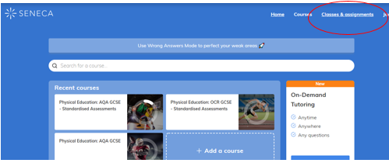
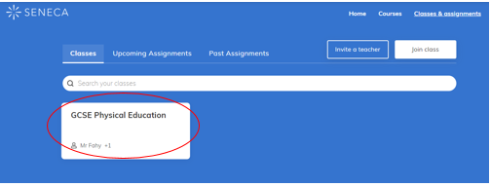
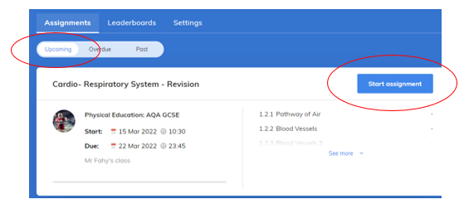
How to find your Seneca assignments:
Step 1: Click on ‘Classes and Assignments’

Step 2: Click on the ‘GCSE Physical Education’ Classroom

Step 3: Click on ‘Upcoming’ assignments (If you have missed assignments then you can click on overdue).

Step 4: Click on ‘Start Assignment’. Please make sure the assignment title matches with correct week.

Class Code: mh2ut6bpy1

