Q1.
A car driver sees a rabbit on the road.
The driver makes an emergency stop after he sees the rabbit.
Figure 6 shows the speed of the car from the time the driver sees the rabbit until the car stops.
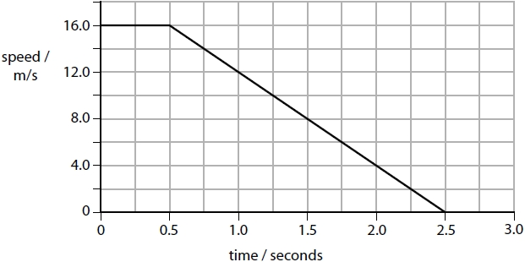
Figure 6
Calculate the distance that the car travels in the first 0.5 seconds.
(3)
distance = ........................................................... m
(Total for question = 3 marks)
Q2.
A car is travelling down a slope at 2.0 m/s.
The car accelerates for 4.0 s.
The speed of the car increases to 12 m/s.
Calculate the acceleration of the car.
Use the equation
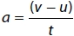
(2)

acceleration of the car = ........................................................... m/s²
(Total for question = 2 marks)
Q3.
Figure 7 shows a skier going down a hill.
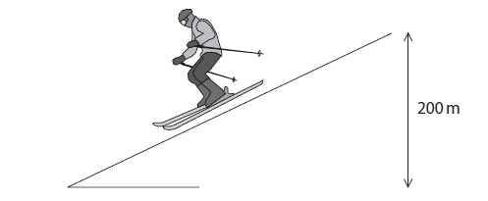
Figure 7
Describe how her speed at the bottom of the slope could be determined.
(3)
.............................................................................................................................................
.............................................................................................................................................
.............................................................................................................................................
.............................................................................................................................................
.............................................................................................................................................
.............................................................................................................................................

(Total for question = 3 marks)
Q4.
An aircraft waits at the start of a runway.
The aircraft accelerates from a speed of 0 m/s to a speed of 80 m/s.
The acceleration of the aircraft is 4 m/s².
Calculate the distance, x, travelled by the aircraft while it is accelerating.
Use the equation
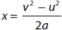
(2)
x = ........................................................... m

(Total for question = 2 marks)

