Combined science higher tier homework Name ……………………………….
Q1. Figure 7 is a velocity/time graph showing a 34 s part of a train's journey.
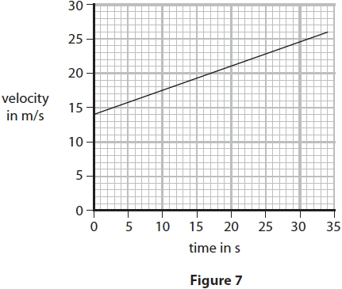
(i) Calculate the acceleration of the train in the 34 s.
Give your answer to an appropriate number of significant figures.
(3)
acceleration = ........................................................... m/s²
(ii) Calculate the distance the train travels in the 34 s.
(3)
distance ........................................................... m

(Total for question = 6 marks)

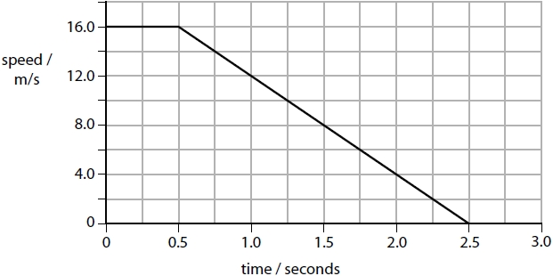
Q2. A car driver sees a rabbit on the road. The driver makes an emergency stop after he sees the rabbit. Figure 6 shows the speed of the car from the time the driver sees the rabbit until the car stops.

Figure 6

Calculate the distance that the car travels in the first 0.5 seconds.
(3)
distance = ........................................................... m
(Total for question = 3 marks)

Q3. Here is the velocity-time graph for a car for the first 20 s of a journey.
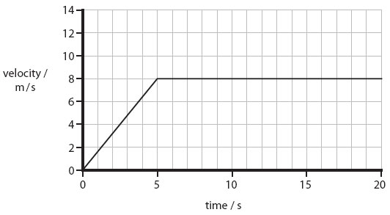
(i) Calculate the change in velocity of the car during the first 5 s.
(1)

..............................................................................................................................................
(ii) Calculate the acceleration of the car during the first 5 s.
(2)

acceleration = ......................m/s²

