WJEC LEVEL 1/2 VOCATIONAL AWARD IN CONSTRUCTING THE BUILT ENVIRONMENT eSAM 4
ASPL Construction Development Services was set up seven years ago and has completed many successful construction projects over this period. The new member of staff, Randel Baker, has recently joined the company and has the responsibility for safety and security issues on all ASPL sites.
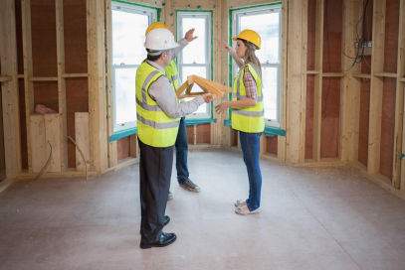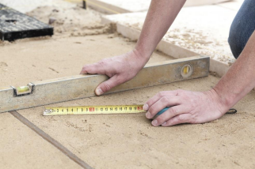
© WJEC CBAC Ltd.
WJEC LEVEL 1/2 VOCATIONAL AWARD IN CONSTRUCTING THE BUILT ENVIRONMENT eSAM 5
Q.1 An employee has e mailed Randel with his concerns over the potential risk of an electrical fire in one of the ASPL offices. He is keen to ensure the most appropriate fire extinguisher is available in the office.
(a) State the most suitable fire extinguisher, in the case of an electrical fire, from those shown below.
……………………………………………………………………………………. [1] 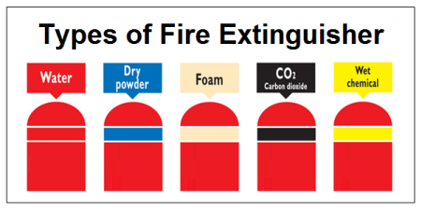(b) Name one other type of fire extinguisher that could be used for an electrical fire. [1]
………………………………………………………………………………………….
© WJEC CBAC Ltd.
WJEC LEVEL 1/2 VOCATIONAL AWARD IN CONSTRUCTING THE BUILT ENVIRONMENT eSAM 6
Q.2 Randel was very concerned that flammable materials have been stored in site offices.
(a) Identify one control measure that will minimise personal injury caused as a result of the storage of flammable materials. [1]
a fire extinguisher placed near to where the boxes are stacked
a lockable storage cupboard
a first aid kit placed on the wall near where the boxes are stacked
(b) Recommend one other control measure that Randel could consider in this instance and state why it would be suitable. [2]
………………………………………………………………………………………… ………………………………………………………………………………………… ………………………………………………………………………………………… ………………………………………………………………………………………… ………………………………………………………………………………………… …………………………………………………………………………………………
(c) Name and describe one piece of legislation that covers the handling of flammable substances. [3]
………………………………………………………………………………………… ………………………………………………………………………………………… ………………………………………………………………………………………… ………………………………………………………………………………………… ………………………………………………………………………………………… ………………………………………………………………………………………… ………………………………………………………………………………………… ………………………………………………………………………………………… …………………………………………………………………………………………
© WJEC CBAC Ltd.
WJEC LEVEL 1/2 VOCATIONAL AWARD IN CONSTRUCTING THE BUILT ENVIRONMENT eSAM 7
Q.3
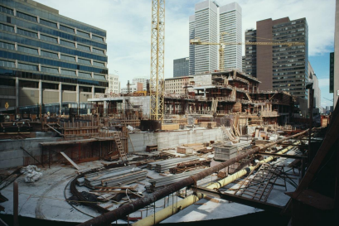
ASPL has major security problems after working hours when sites are prone to theft and vandalism. This is especially true of city centre developments.
Describe two control measures ASPL could use in order to protect their sites. Control Measure 1 [2] …………………………………………………………………………………………………………… …………………………………………………………………………………………………………… …………………………………………………………………………………………………………… …………………………………………………………………………………………………………… ……………………………………………………………………………………………………………
Control Measure 2 [2] …………………………………………………………………………………………………………… …………………………………………………………………………………………………………… …………………………………………………………………………………………………………… …………………………………………………………………………………………………………… ……………………………………………………………………………………………………………
© WJEC CBAC Ltd.
WJEC LEVEL 1/2 VOCATIONAL AWARD IN CONSTRUCTING THE BUILT ENVIRONMENT eSAM 8
Q4
Key members of ASPL staff are issued with laptops (or tablets) and phones. The information stored on these machines is often confidential and can include personal details of workers and important information about site activities. Staff tend to take the devices home with them so that they can complete work outside normal working hours.
(a) Identify two risks to security of ASPL staff having devices containing personal information of staff and site activities. [2]
………………………………………………………………………………………………….. ………………………………………………………………………………………………….. ………………………………………………………………………………………………….. …………………………………………………………………………………………………..
(b) Describe a measure that could be put in place to mimimise the risks to security created by the use of the devices. [2]
………………………………………………………………………………………………….. ………………………………………………………………………………………………….. ………………………………………………………………………………………………….. …………………………………………………………………………………………………..
© WJEC CBAC Ltd.
WJEC LEVEL 1/2 VOCATIONAL AWARD IN CONSTRUCTING THE BUILT ENVIRONMENT eSAM 9
Q5
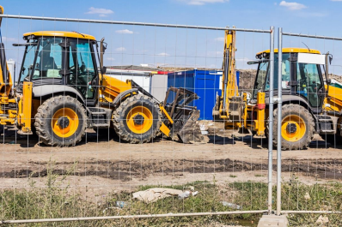Photograph A
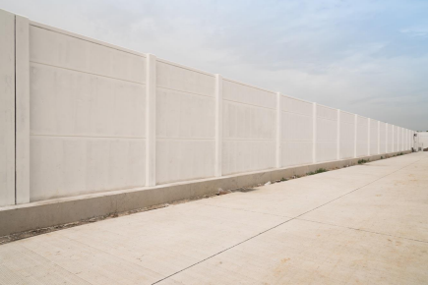Photograph B
It has been noted that the security fence surrounding our Cambridge site (as shown in photograph A) is of a very lightweight construction. The perimeter fence at one of our developments in Manchester (as shown in photograph B) is more substantial.
© WJEC CBAC Ltd.
WJEC LEVEL 1/2 VOCATIONAL AWARD IN CONSTRUCTING THE BUILT ENVIRONMENT eSAM 10
Explain why the lightweight perimeter fence at the Cambridge site (as shown in photograph A) may be a security risk. [4]
…………………………………………………………………………………………………………… …………………………………………………………………………………………………………… …………………………………………………………………………………………………………… …………………………………………………………………………………………………………… …………………………………………………………………………………………………………… …………………………………………………………………………………………………………… …………………………………………………………………………………………………………… …………………………………………………………………………………………………………… …………………………………………………………………………………………………………… ……………………………………………………………………………………………………………
Q.6 Safety signs are a very important part of health and safety practice on all of ASPL’s sites and offices.
(a) The following table lists safety signs and sign types. Match each safety sign to the correct sign type. [5]
Safety sign |  | Sign type
Yellow triangular sign |  | Mandatory (must do)
Blue Circular sign |  | Prohibition (do not)
Red circular sign with  pedestrian image on a white background |  | Fire sign (fire equipment)
Red sign featuring an image of a fire extinguisher |  | Safe condition (the safe way)
Green oblong sign stating 'Fire Exit' |  | Warning (beware or Caution)

© WJEC CBAC Ltd.
WJEC LEVEL 1/2 VOCATIONAL AWARD IN CONSTRUCTING THE BUILT ENVIRONMENT eSAM 11
Q.7
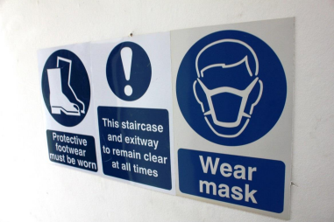Randel is very keen to ensure that all staff and contractors are wearing the appropriate Personal Protective Equipment (PPE) and now ensures that signs, as shown in the photograph are used on all ASPL sites.
State Four construction site operations where ASPL would insist on the use of PPE and identify the associated item of PPE that should be used. [8]
Building site operation | Associated item of PPE

© WJEC CBAC Ltd.
WJEC LEVEL 1/2 VOCATIONAL AWARD IN CONSTRUCTING THE BUILT ENVIRONMENT eSAM 12
Q8
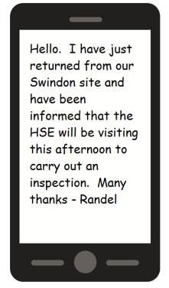
Randel needs to gather information about the Health and Safety Executive (HSE), in particular the powers they have.
Describe two main powers of the Health and Safety Executive. [4] Power 1
................................................................................................................................................... ................................................................................................................................................... ................................................................................................................................................... ................................................................................................................................................... Power 2
................................................................................................................................................... ................................................................................................................................................... ................................................................................................................................................... ...................................................................................................................................................
© WJEC CBAC Ltd.
WJEC LEVEL 1/2 VOCATIONAL AWARD IN CONSTRUCTING THE BUILT ENVIRONMENT eSAM 13
Q9
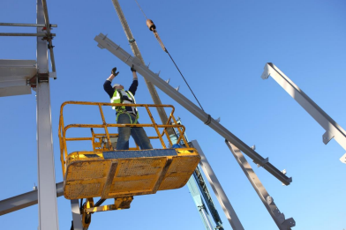
This photograph was taken at our Wrexham site and shows a worker erecting a steel structure 20 metres above ground level.
(a) Name a piece of legislation that covers the health and safety of this worker. [1]
………………………………………………………………………………………………… …………………………………………………………………………………………………
(b) Give two responsibilities of ASPL under this law. [2]
………………………………………………………………………………………………… ………………………………………………………………………………………………… ………………………………………………………………………………………………… ………………………………………………………………………………………………… ………………………………………………………………………………………………… ………………………………………………………………………………………………… ………………………………………………………………………………………………… …………………………………………………………………………………………………
© WJEC CBAC Ltd.
WJEC LEVEL 1/2 VOCATIONAL AWARD IN CONSTRUCTING THE BUILT ENVIRONMENT eSAM 14
Q.10
The following photographs (1 – 4) show scenes from various ASPL sites which have been created for training purposes.
You are to write a short report for each of the situations shown in the photographs, your reports should identify possible hazards (one per situation), describe the associated risks and suggest suitable control measures to control the risks. [4 x 5]
Photo 1
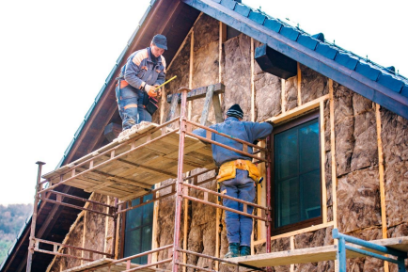…………………………………………………………………………………………………………… …………………………………………………………………………………………………………… …………………………………………………………………………………………………………… …………………………………………………………………………………………………………… ……………………………………………………………………………………………………………
…………………………………………………………………………………………………………… …………………………………………………………………………………………………………… …………………………………………………………………………………………………………… …………………………………………………………………………………………………………… ……………………………………………………………………………………………………………
© WJEC CBAC Ltd.
WJEC LEVEL 1/2 VOCATIONAL AWARD IN CONSTRUCTING THE BUILT ENVIRONMENT eSAM 15
Photo 2
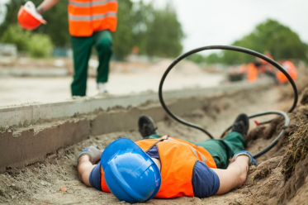
…………………………………………………………………………………………………………… …………………………………………………………………………………………………………… …………………………………………………………………………………………………………… …………………………………………………………………………………………………………… …………………………………………………………………………………………………………… …………………………………………………………………………………………………………… …………………………………………………………………………………………………………… …………………………………………………………………………………………………………… …………………………………………………………………………………………………………… ……………………………………………………………………………………………………………
© WJEC CBAC Ltd.
WJEC LEVEL 1/2 VOCATIONAL AWARD IN CONSTRUCTING THE BUILT ENVIRONMENT eSAM 16
Photo 3
…………………………………………………………………………………………………………… …………………………………………………………………………………………………………… …………………………………………………………………………………………………………… …………………………………………………………………………………………………………… …………………………………………………………………………………………………………… …………………………………………………………………………………………………………… …………………………………………………………………………………………………………… …………………………………………………………………………………………………………… …………………………………………………………………………………………………………… ……………………………………………………………………………………………………………
© WJEC CBAC Ltd.
WJEC LEVEL 1/2 VOCATIONAL AWARD IN CONSTRUCTING THE BUILT ENVIRONMENT eSAM 17
Photo 4
…………………………………………………………………………………………………………… …………………………………………………………………………………………………………… …………………………………………………………………………………………………………… …………………………………………………………………………………………………………… …………………………………………………………………………………………………………… …………………………………………………………………………………………………………… …………………………………………………………………………………………………………… …………………………………………………………………………………………………………… …………………………………………………………………………………………………………… ……………………………………………………………………………………………………………
© WJEC CBAC Ltd.
WJEC LEVEL 1/2 VOCATIONAL AWARD IN CONSTRUCTING THE BUILT ENVIRONMENT eSAM 18
WJEC Level 1/2 Vocational Awards in Constructing the Built Environment
Unit 1: Safety and Security in Construction External Assessment
60 Marks
Mark Scheme
Sample Assessment
© WJEC CBAC Ltd.
VOCATIONAL AWARD CONSTRUCTING THE BUILT ENVIRONMENT eSAM 19
Question | Answer | Marks
1. (a)  AC1.3 | 1 mark for correct answer  Answer:  Dry Powder or CO₂ | 1
1. (b)  AC1.3 | 1 mark for correct answer  Answer: (1 of 3)  Dry Powder or CO₂ | 1
2. (a)  AC3.2 | 1 mark for correct answer  Answer:  A lockable storage cupboard | 1
2. (b)  AC3.2 | Up to 2 marks available  1 mark for basic recommendation – eg to store off site and away from most workers  2 marks for stating its suitability ie being away from offices reduces the risk for workers  Indicative content  If flammable materials are kept off site then staff would be less likely to have any contact with them. Therefore, there is less likelihood of a fire starting and injuries occurring.  Candidate may suggest having a purpose built storage facility with fire prevention capabilities and an associated statement of its suitability as a control measure.  Any other appropriate response.  Example 2 mark answer:  When the flammable materials are stored in a location away from the offices and workers, in the event of a fire, the workers would be safer (2). | 2

© WJEC CBAC Ltd.
VOCATIONAL AWARD CONSTRUCTING THE BUILT ENVIRONMENT eSAM 20
Question | Answer | Marks
2.(c)  AC1.1 | Up to three marks available  COSHH – Control of substances hazardous to health. (1) for identification – full title not required COSHH is sufficient.  Description – This legislation requires employers to control hazardous substances(1) to prevent or reduce workers exposure(1).  HASAWA would be acceptable (1) however, the associated description would need to be specific to hazardous substances as opposed to a generic description. | 3
3.  AC4.2 | Up to 2 x 2 marks available  For each control measure:  1 mark for identifying an appropriate control measure  2 marks with description of appropriate reason  Indicative content  ∙ Security cameras / CCTV  ∙ Security staff  ∙ Alarm system  ∙ Perimeter fence / Hoarding  ∙ Any other appropriate response  Example 2 mark answer:  A security fence could be put up around the perimeter of the site (1) this would make it difficult for unauthorised people to access the site (1). | 4
4. (a)  AC4.1 | Up to 2 marks available. One mark for each identified risk to security. Typical responses include:  ∙ when taken away from work premises, devices may be less secure and could be stolen or accidentally mislaid (1)  ∙ personal information on devices could be accessed after theft and used for illegal purposes  ∙ information on site activities could be accessed including: o material delivery dates  o sub-contractor information  o budget information | 2

© WJEC CBAC Ltd.
VOCATIONAL AWARD CONSTRUCTING THE BUILT ENVIRONMENT eSAM 21
Question | Answer | Marks
4. (b)  AC4.2 | Up to 2 marks available. 2 marks for a description of a legitimate measure.  Typical responses include:  ∙ Password protection (1) personal login details would make it more difficult for any un-authorised users to access (1)  ∙ Laptops may not be taken off the work premises (1), kept in a secure location when not in use (1)  ∙ Information on phones and laptops to be uploaded onto a network(1) and then deleted from the device used, so no confidential information is left on laptops or phones(1) | 2
5.  AC4.1 | Up to 4 marks are available  Maximum marks can be awarded for one reason explained in detail or two reasons explained  1 mark for identifying a reason for a security risk  1 additional mark can be awarded for describing security risk in detail Additional marks for reasoning in response  Indicative content  ∙ Members of the public could enter the site  ∙ Injuries to unauthorised people  ∙ Equipment or materials stolen  ∙ Vandalise the buildings and equipment  ∙ Safety measures that are in place are tampered with  Example 4 mark answer:  Members of the public could enter the site (1) by easily gaining access through the lightweight fence (1). Vandalism of other security measures such as CCTV cameras could take place (1) and this could lead to further security risks (1). | 4
6.  AC1.2 | One mark for each correct match  Safety sign Sign type  Yellow triangular sign Warning (beware or Caution) Blue circular sign Mandatory (must do) Red circular sign with a  Prohibition (do not)  pedestrian image on a white  background  Red sign featuring an image of a  Fire sign (fire equipment)  fire extinguisher  Green oblong sign stating 'Fire  Safe condition (the safe way)  Exit' | 5

© WJEC CBAC Ltd.
VOCATIONAL AWARD CONSTRUCTING THE BUILT ENVIRONMENT eSAM 22
Question | Answer | Marks
7  AC3.1 | Up to 8 marks available 4 x 2  Correctly identify one or more Control measure (1)  Explanation of why they are required (2)  Indicative Content  1 High visability vest - signage - routes separated - people separated, traffic lights  2 Breathing apparatus, platforms, permits to work, training, ventilation  3 Harnesses training - risk assessment people processes 4 Signage - barriers - Training - Permits to work.  No material storage next to the trench. | 8
8.  AC1.4 | Up to 4 marks available  1 mark for stating two main powers:  Power 1 – issue an improvement notice  Power 2 – issue a prohibition notice  Power 3 – prosecute  1 mark for providing a description of the main power stated:  ∙ A requirement to improve an identified aspect of the site operation  ∙ All work stopped until required action(s) are taken  ∙ Court action can be taken in the form of prosecution  Any other reasonable response which correctly states then describes one of the main powers of the HSE | 4
9. (a)  AC1.1 | Working at height regulations  Health and Safety at work act  (dates not required)  Any other acceptable piece of legislation | 1
9. (b)  AC1.1 | Up to 2 marks available. Responsibilities of ASPL:  Working at height regulations:  ∙ Work is properly planned  ∙ Work is properly supervised  ∙ Work is carried out by competent people  HASAWA:  ∙ To protect their worker's health and safety  ∙ To protect other people who may be affected by the site work ∙ To control potential risks to injury or health | 2

© WJEC CBAC Ltd.
VOCATIONAL AWARD CONSTRUCTING THE BUILT ENVIRONMENT eSAM 23
Question | Answer | Marks
10.  AC2.1  AC2.2  AC3.2 | Reports to include the identification of a hazard (1), the description of risk(s) (2) and suggestions for appropriate control measures (2).  Photo 1  Hazard identified (one mark maximum)  Many hazards can be noted including:  ∙ Insubstantial platform  ∙ No barrier to prevent falls  ∙ No apparent signage  ∙ No hard hat worn by workers  ∙ Accept no mask or goggles as working with insulation material ∙ Any other appropriate response  Description of risks (two marks maximum)  ∙ Potential collapse of platform  ∙ Potential falls from platform  ∙ Health risks as a result of material being used especially to respiratory  ∙ Any other appropriate response  Control measures suggested (two marks maximum)  ∙ Replace existing platform with a more substantial one which includes flat stable working surfaces  ∙ Ensure platform has barrier to prevent falls  ∙ Proper access to all levels of the platform  ∙ Signage for PPE – (Hard hat, mask and goggles)  ∙ Any other appropriate response  Photo 2  Hazard identified (one mark maximum)  Two main hazards can be noted:  ∙ Ditch with no barrier  ∙ Electric cable (possibly live and exposed)  ∙ Any other appropriate response  Description of risks (two marks maximum)  ∙ Trip and fall hazard (into ditch)  ∙ Trip and fall hazard (from wire)  ∙ Electrocution  Control measures suggested (two marks maximum)  ∙ Wire could be properly laid and isolated to minimise risks of ∙ Wire could be insulated  ∙ Barrier could be installed  ∙ Signage could be displayed | 1  2  2  1  2  2

© WJEC CBAC Ltd.
VOCATIONAL AWARD CONSTRUCTING THE BUILT ENVIRONMENT eSAM 24
 | Photo 3  Hazard identified (one mark maximum)  ∙ Excessive noise  ∙ Any other appropriate response  Description of risks (two marks maximum)  ∙ Damage to ears  ∙ Loss of concentration which could lead to injury of self or others ∙ Any other appropriate response  Control measures suggested (two marks maximum)  ∙ Ensure ear protection must worn – checks can be made by supervisory staff  ∙ Suppression or reduction of source of noise – dependent on source i.e. improved  ∙ Any other appropriate response  Photo 4  Hazard identified (one mark maximum)  ∙ No Gloves  ∙ No hard hat  ∙ No safety goggles  ∙ No ear defenders  ∙ No overalls  ∙ No guard on machine  ∙ Any other appropriate response  Description of risks (two marks maximum)  ∙ Injuries to hand (as photo)  ∙ Head injuries  ∙ Eye injury  ∙ Loss of hearing – temporary or permanent ear damage ∙ Loose clothes getting caught in machine with subsequent injury ∙ Any other appropriate response  Control measures suggested (two marks maximum)  ∙ Guard to be installed  ∙ Signage for PPE to be worn at all times  ∙ Operative training  ∙ Signing-in process in which operative confirms when they have started to use the machinery and their adherence to safety requirements  ∙ Requirement for a Permit to Work  ∙ Any other appropriate response | 1  2  2  1  2  2

© WJEC CBAC Ltd.
VOCATIONAL AWARD CONSTRUCTING THE BUILT ENVIRONMENT eSAM 25
Unit 1 SAM mark distribution
Assessment Criteria | Question | Total | Mark parameters
1.1 | 9(a) 9(b) 2(c) | 6
1.2 | 6 | 5
1.3 | 1(a) 1(b) | 2
1.4 | 8 | 4
Sub total |  | 17 | 12 - 18
2.1 | 10 | 4
2.2 | 10 | 8
2.3
Sub total |  | 12 | 12 - 18
3.1 | 7 | 8
3.2 | 2(a)2(b) 10 | 11
Sub total |  | 19 | 18 - 24
4.1 | 4(a) 5 | 4
4.2 | 3 4(b) 5 | 8
Sub total |  | 12 | 6 - 12
Total |  | 60

WJEC level 1/2 Awards in Constructing the Built Environment eSAMs Unit 1/HB
05.02.18
© WJEC CBAC Ltd.

