SECTION A - Core Technical Principles
Questions 1-10 are multiple choice questions. For multiple choice questions you should shade in one lozenge. If you make a mistake, cross through the incorrect answer and shade the correct response.

1: Which of the following power sources is classed as a fossil fuel? [1 mark]
⬨ Hydroelectric
⬨ Natural gas
⬨ Nuclear
⬨ Tidal

2: Figure 1 shows an inflated balloon being held.
Figure 1
What is the force that is acting upon the air inside the balloon? [1 mark]
⬨ Compression
⬨ Shear
⬨ Tension
⬨ Torsion

3: What is the voltage of a single cell found in a non-rechargeable AA battery? [1 mark]
⬨ 1.5 volts
⬨ 3 volts
⬨ 5 volts
⬨ 12 volts

4: Which of the following materials change state in response to ultraviolet light? [1 mark]
⬨ Graphene
⬨ Photochromic pigment
⬨ Shape memory alloy
⬨ Thermochromic pigment

5: Which of the following is used as an output component? [1 mark]
⬨ Heat sensor
⬨ Lamp
⬨ Pressure sensor
⬨ Switch

6: Which motion best describes a child’s swing in use? [1 mark]
⬨ Linear
⬨ Oscillating
⬨ Reciprocating
⬨ Rotary

7: State the value of the weight needed at point A in figure 2 for the scales
to balance? [1 mark]
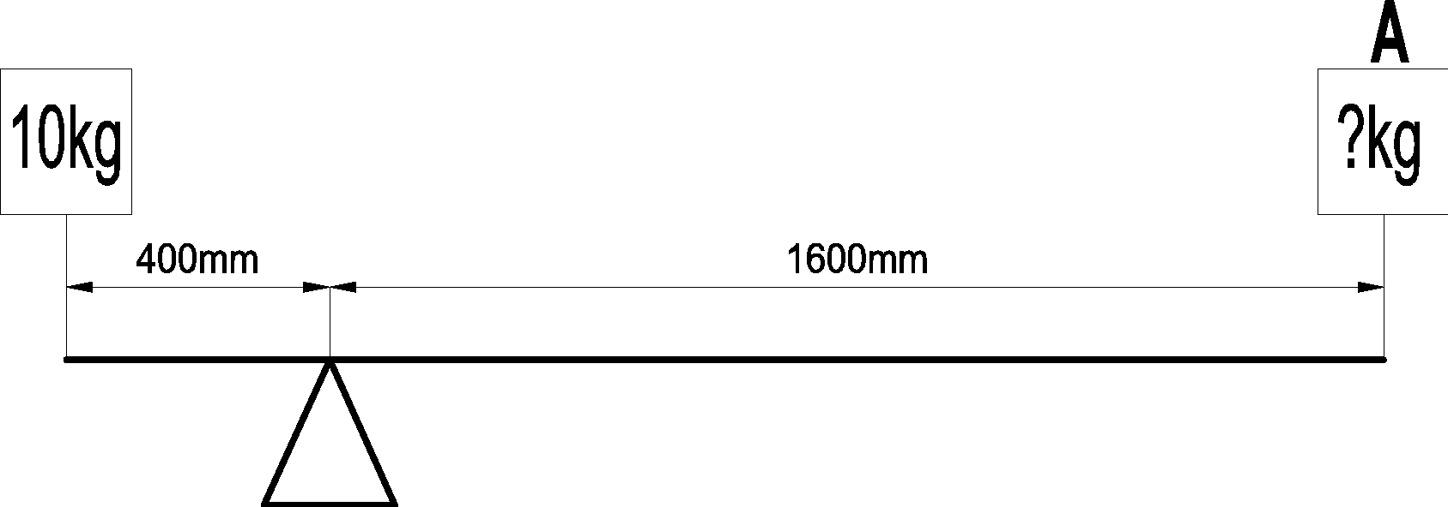
Figure 2
⬨ 2.5kg
⬨ 3.3kg
⬨ 5kg
⬨ 10kg

8: Which one of the following cams can only be rotated in a single direction? [1 mark]
⬨ Eccentric
⬨ Heart
⬨ Pear
⬨ Snail

9: Which of the following is a ferrous metal? [1 mark]
⬨ Aluminium
⬨ Low carbon steel
⬨ Tin
⬨ Zinc

10: Figure 3 shows a rotary system.
Figure 3

What is the name of the rotary system in figure 3 above? [1 mark]
⬨ Chain and sprocket
⬨ Crank and slider
⬨ Gear train
⬨ Pulley and belt

11: State two properties or characteristics that make medium density fibreboard
(MDF) suitable for use in flatpack furniture. [2 marks]
1.

2.

12: State two reasons why high-speed steel (HSS) is used for cutting tools. [2 marks]
1.

2.

13.1: The Committee on Climate Change state that 40% of the UK’s emissions come from households. In 1990 each household produced an average of 12.8 tonnes of C0₂, in 2014 this had reduced to 8.1 tonnes.
Give two reasons why the amount of CO₂ per household has reduced
during this period. [2 marks]
1.

2.

13.2: The target for household emissions by 2030 is 4.5 tonnes per household.
Explain how households could change their behaviours to help meet
this target. [2 marks]

13.3: If the target for 2030 of 4.5 tonnes per household is met, what would be the percentage reduction from the 1990 level of 12.8 tonnes per household? [2 marks]
Show your working out and give your answer to 1 decimal point.

