SECTION B - Specialist Technical Principles
Finishing treatments and techniques
Specialist finishing techniques include:
Tanalising | Spot (UV) varnishing | Stain protection
Self-adhesive decals | PCB lacquering (conformal coating) | Plastic dip coating
14.1: Choose one specialist treatment or technique from the list above.
Name of chosen specialist treatment or technique
Give one reason why the treatment or technique is used. [1 mark]

14.2: In the box below, use notes and sketches to explain how your chosen
treatment or technique from 14.1 is performed using an appropriate
material(s) of your choice. [4 marks]

15: Give two reasons why tolerances are used in designing and manufacturing products.
Give one example in each of your answers.
1. [2 marks]

2. [2 marks]

16.1: Choose one product, material or component in figure 4 and describe two features that make it suitable for computer aided manufacturing (CAM).
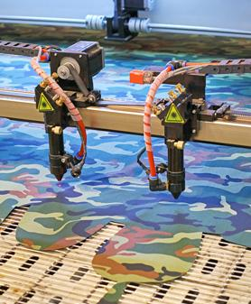 | 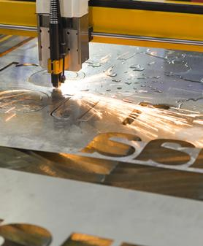 | 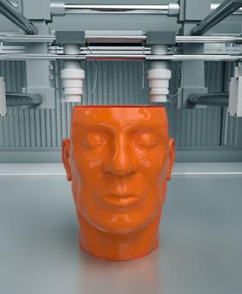
Laser cut clothes | Laser cut metal signage | 3D printed polymer parts
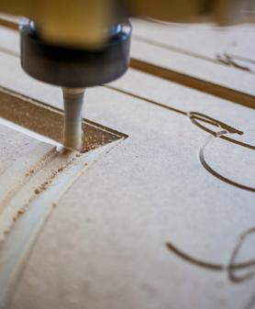 |  | 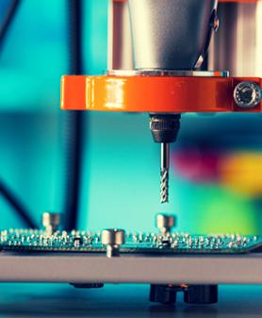
CNC routed furniture | Laser cut card stationary | CNC routed PCB
Figure 4
Name of chosen product, material or component
Feature 1 [2 marks]

Feature 2 [2 marks]

16.2: Choose one specific computer aided manufacturing process that you are familiar with. This may have been one used on your chosen product/component/material in 16.1.
Name of chosen specialist CAM process
In the box below, use notes and sketches to explain a CAM process
in detail. [4 marks]

