Year 11 Geography homework – Cycle 3 Week 4
Theme 1: Changing places – Changing economies
- AO1 (knowledge)- Name the key process (4 marks)
________________ - an area of a town or city where no vehicles are allowed
________________ - a group of countries that trade without tariffs or quotas
__________________ - the imaginary line between the north and south of the UK – e.g. a lower life expectancy in the south
________________ - the process of the world becoming more connected

- AO2 (understanding) – answer the question below in full sentences (4 marks)
Describe the pattern of where most global cities are found today and how that might change in the future.
…………………………………………………………………………………………………………………………………………………………………………………………………………………………………………………………………………………………………………………………………………………………………………………………………………………………………………………………………………………………………………………………………………………………………………………………………………………………………………………………………………………………………………………………………………………..
- AO4 (skills) – 4 marks
Complete the table below with the most appropriate graph for each type of data (line graph/bar graph/pie chart/kite diagram)
Sampling strategy/method | Description
 | The amount of rainfall in different locations in the UK on one day
 | The population of Mumbai from 1900 to 2000 (data every 10 years)
 | The amount of vegetation (plants) along a straight line transect on a sand dune – measured over 100m
 | The % of stakeholders who strongly agree/agree/disagree/strongly disagree that sea walls are effective

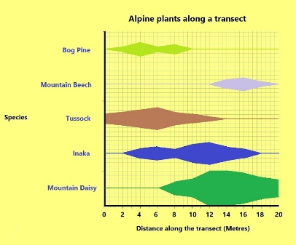 Kite diagram
Stretch yourself: Why are these graphs appropriate? Give a reason for each using terms such as discrete and continuous data

