Week4 science (higher tier) homework name ……………………………….
Q1. Figure 1 shows the number of people per million of the population in five
European countries who were diagnosed with measles in one year.
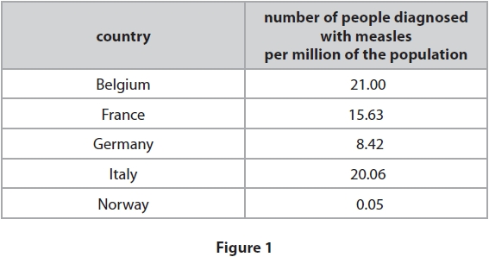
(i) The population of Belgium in that year was 11.18 million. Calculate the number of people in Belgium diagnosed with measles. Give your answer to three significant figures.
(3)
........................................................... people
(ii) Countries do not report the total number of people diagnosed with measles.
Countries report the number of people diagnosed with measles per million of the population.
Give one reason why this is better.
(1)
.............................................................................................................................................
.............................................................................................................................................
(iii) Give one reason why the number of people per million diagnosed with
measles is different in these countries.
(1)
.............................................................................................................................................
.............................................................................................................................................
.............................................................................................................................................
(Total for question = 5 marks)
Q2. Tuberculosis (TB) is a communicable disease.
(i) State two ways that communicable diseases are different from non-communicable diseases.
(2)
1 ..........................................................................................................................................
.............................................................................................................................................
2 ..........................................................................................................................................
.............................................................................................................................................
(ii) Explain one way that the spread of tuberculosis (TB) can be reduced or prevented.
(2)
.............................................................................................................................................
.............................................................................................................................................
.............................................................................................................................................
.............................................................................................................................................
(Total for question = 3 marks)
Q3. Explain why people with AIDS are more susceptible to TB.
(2)
.............................................................................................................................................
.............................................................................................................................................
.............................................................................................................................................
.............................................................................................................................................
(Total for question = 2 marks)
Q4.Streptococcus bacteria can cause a sore throat or skin infection. An illness called scarlet fever can also develop during an infection with this bacterium.
(i) Give two precautions a doctor should take when treating a patient who is infected with Streptococcus.
(2)
.............................................................................................................................................
.............................................................................................................................................
.............................................................................................................................................
.............................................................................................................................................
.............................................................................................................................................
(ii) From September 2013 to March 2014 there were 2 830 cases of scarlet fever in the UK.
From September 2014 to March 2015 there were 5 943 cases of scarlet fever.
Calculate the percentage increase of the number of cases of scarlet fever between the periods September 2014 to March 2015 and September 2013 to March 2014.
(2)
........................................................... %
(iii) Some bacteria are motile, meaning they can move themselves. Why is a Streptococcus bacterium not motile?
(1)
A it does not have flagella
B it does not have plasmids
C it does not have ribosomes
D it does not have acrosomes
(Total for question = 5 marks)

