Q1.
Antibiotics can be used to treat Chlamydia, which is a sexually transmitted infection.
(a) What type of pathogen causes Chlamydia?
(1)
A bacteria
B fungus
C protist
D virus
Figure 4 shows the number of new cases of Chlamydia diagnosed each year, in a region of the UK, between 2000 and 2008.
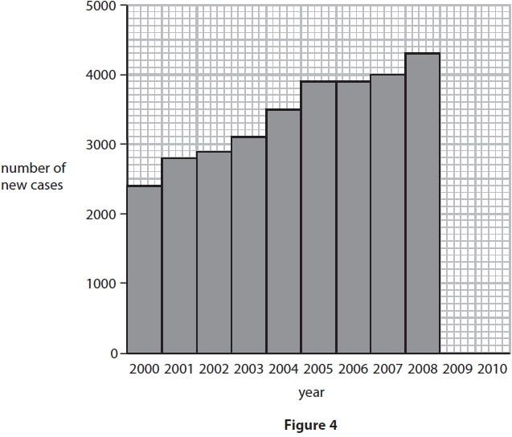
(b) (i) In 2009 there were 4800 new cases diagnosed.
In 2010 there were 4100 new cases diagnosed.
Plot this data on the graph in Figure 4.
(1)
(ii) Describe the trend in cases between 2000 and 2010.
(2)
.............................................................................................................................................
.............................................................................................................................................
.............................................................................................................................................
.............................................................................................................................................
People infected with Chlamydia are more likely to be infected with the STI Gonorrhoea.
(iii) Explain how people become infected with both Chlamydia and Gonorrhoea.
(2)
.............................................................................................................................................
.............................................................................................................................................
.............................................................................................................................................
.............................................................................................................................................
(Total for question = 6 marks)
Q2.
The human immune system helps defend the body against disease.
Bacteria and other microorganisms can cause infectious diseases.
Use the words in the box to complete the passage about treating infectious diseases.
(3)
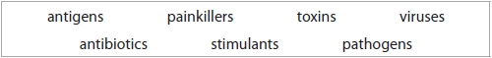
Bacteria and other microorganisms that cause infectious diseases are called ........................................................................ . Drugs called ........................................................................ can be used to treat infectious diseases caused by bacteria. These drugs do not work against infectious diseases caused by ........................................................................ .
(Total for question = 3 marks)
Q3.
Colistin is an antibiotic used to treat infections in the bloodstream.
Some bacteria are resistant to Colistin.
Explain how these bacteria have become resistant to Colistin.
(4)
.............................................................................................................................................
.............................................................................................................................................
.............................................................................................................................................
.............................................................................................................................................
.............................................................................................................................................
.............................................................................................................................................
.............................................................................................................................................
.............................................................................................................................................
(Total for question = 4 marks)

