Year 11 Homework Computer Science
Name
Cycle | 1 | Week | 2
Hand in Date

What do you call a computer system which can be re-programmed? ………………………………………………………………………………………………….………………………………………………...……………...…………
What is a constant, & what data type would be best to store your name? …………………………………………………………………………………………………….………………………………………………..………………………
Programming Writing  Please write a function called Speed which takes 2 parameters - time in seconds and distance travelled in meters, which returns your speed in m/s.  def ____________ (__________, ________):  return _____________  Programming Reading (OCR Reference)  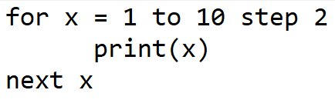  Please write out the numbers this iteration would creation  __________________________________ | Programming Reading  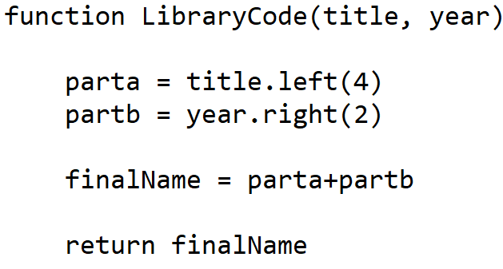  How many parameters does this function have? ______  What would be returned from this:  LibraryCode(“Hobbit”, 1999) __________  LibraryCode(“Social Network”, 2020) _________  Does this code contain?  Technique Tick  Selection  Sequence  Iteration
