Year 11 Homework Computer Science
Name
Cycle | 1 | Week | 3
Hand in Date

State one kind of primary storage

………………………………………………………………………………………Which part of the processor is responsible for controlling the FDE cycle?
………………………………………………………………………………………
Programming Writing  Please draw a flowchart  (use the correct shapes) which:  inputs your name  inputs your age  Checks if you are older than 18  Outputs you can buy alcohol if you are over 18, or you cannot buy alcohol if you are not. | Programming Reading  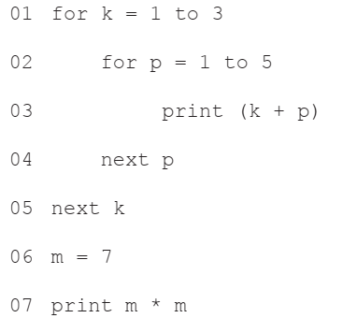  1: What are the first 3 numbers printed?  _________________________________________  2: State how many times line 03 will be executed ______  Tick which of the following is present  Technique Tick  Selection  Sequence  Iteration
