Year 11 Homework Computer Science
Name
Cycle | 1 | Week | 4
Hand in Date

What is 1011 1000 in Hexadecimal? _______  What is 1011 1000 in denary? ________ | What shift would be used to half the value of 1011 1000? _______  Demonstrate that shift _________________
Programming Writing  A theme park aimed at children and adults sells tickets online. An adult ticket to OCR Land costs £19.99, with a child ticket costing £8.99. A booking fee of £2.50 is added to all orders.  (a) A function, ticketprice(), takes the number of adult tickets and the number of child tickets as parameters. It calculates and returns the total price to be paid.  Please write this function using Python.  (no structure this time to help!) | Programming Reading  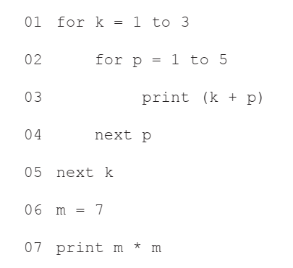  1: What are the first 3 numbers printed?  _________________________________________  2: State how many times line 03 will be executed  ______  Tick which of the following is present  Technique Tick  Selection  Sequence  Iteration
