Year 11 Homework
Subject | History
Cycle | 1 | Week | 2
Hand in Date | Week commencing 19/09/22
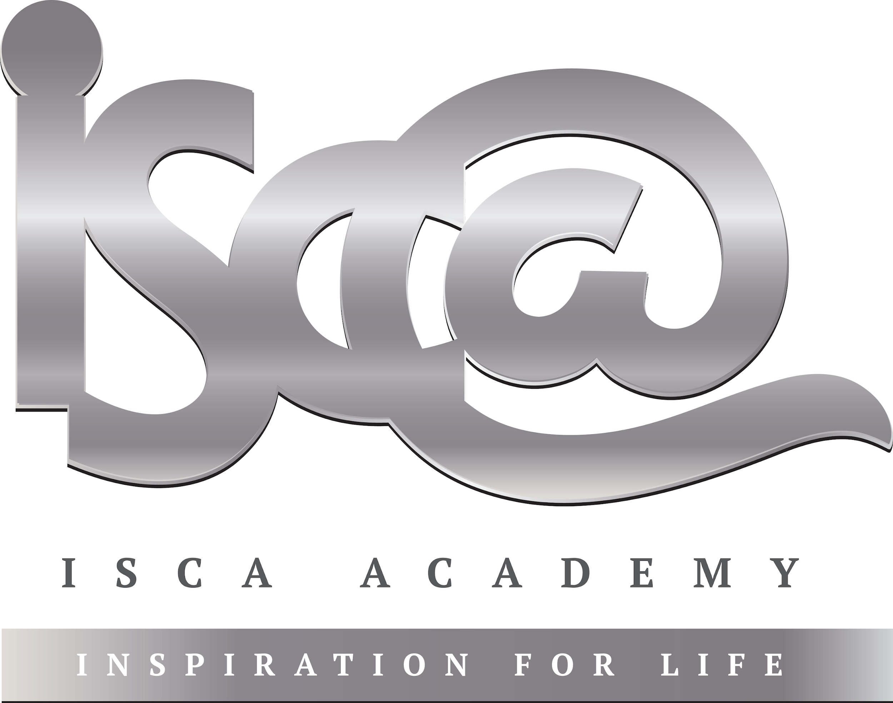
Step 1: Complete the Week 2 Seneca quiz (class code: cx76l0q9h8) – If you don’t yet have a login please speak to your History teacher. Tick the box below to show that you’ve done it and enter the time you’ve spent on this week’s quiz.

Seneca complete □ Time spent:____________________

Step 2: Complete the tasks below:

- Label what you can see happening in the source below.
- Finish the sentence: ‘The source tells me that Elizabeth was____________________________________________________________________________________
____________________________________________________________________________________________________________________________________________________________________________________________________________________________________________________________________________________
__________________________________________________________________________________________________________________________________________

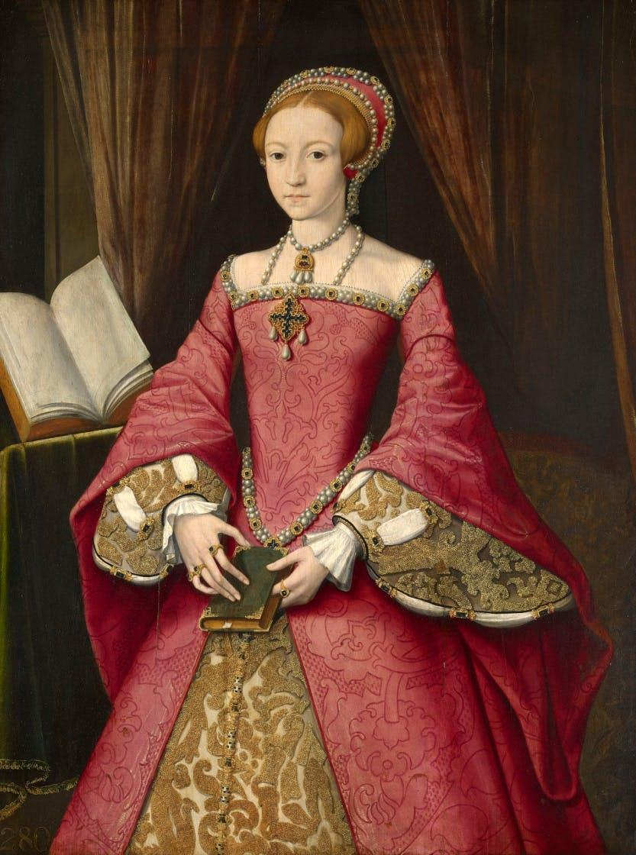

Portrait of Elizabeth I aged 13. Painted in 1546

