Week 1 FT science homework name …………….….. class …………………….
Q1.
Some metals are found in the Earth's crust as uncombined elements. Reactive metals are found in ores.
In ores, metals are combined with other elements. Which of these metals is found as the uncombined element in the Earth's crust?
Hint: uncombined means that the metal is not bonded to another substance. This would be an unreactive metal.
(1)
A aluminium
B gold
C potassium
D zinc

Q2.
Three different metals are added to separate test tubes of acid. The observations are shown in Figure 2.
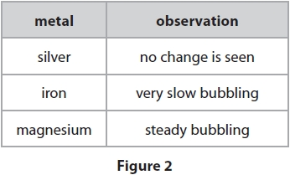
Hint: you need to use the observation to decide the order of reactivity. E.g. the more bubbles that are seen the more reactive it is.
(i) Place the metals in order of reactivity from most to least reactive.
(1)
most reactive ...........................................................
...........................................................
least reactive ...........................................................

(ii) Hydrogen is given off when magnesium reacts with acid. The hydrogen is tested by collecting the gas in a test tube and igniting it. What is the safest way to ignite the gas?
Hint: underlined the key information in the question.
Try to deduce the answer, there are normally 1-2 that are not appropriate e.g. ‘add fuel to the test tube.
(1)
A add fuel to the test tube
B heat the test tube with a Bunsen burner
C put a lighted splint at the open end of the test tube
D put the test tube in an oven
(iii) State the observation made in this test that shows that the gas is hydrogen.
If hydrogen is present when it is ignited you will hear ..........................................................
.............................................................................................................................................

Q3. Use words from the box to complete the sentences.
(2)
(i) Iron is extracted from its ore by heating the ore with ......................................
.
(ii) It is difficult to reduce aluminium ore to aluminium metal. Therefore,

to produce aluminium from its ore, it is necessary to use ..................................... .

Q4. Most metals are extracted from ores found in the Earth's crust. The method used to extract a metal from its ore is linked to the reactivity of the metal.
Part of the reactivity series is shown in Figure 14.
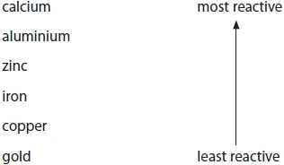
Hint: carbon would be between iron zinc and aluminium
Figure 14
Aluminium cannot be extracted by heating its oxide with carbon. Aluminium has to be extracted from its oxide by electrolysis.
Predict the method that will have to be used to extract calcium from its ore.
(1)
Calcium will be extracted by ..........................................................................................................................

Q5. Iron is extracted by heating iron oxide with carbon. Electrolysis of molten iron oxide is not used to extract iron. Hint: look at the reactivity series above.
(i) State why iron can be extracted by heating iron oxide with carbon.
(1)
Iron can be extracted by heating with carbon because ......................................................
.............................................................................................................................................
(ii) State why electrolysis is not used to extract iron.
(1)
.............................................................................................................................................
.............................................................................................................................................
.............................................................................................................................................
.............................................................................................................................................
(Total for question = 2 marks)

