Week 1 separate science homework Name …………………… class …………….
Q1. The diagram shows four Stone Age tools discovered at different archaeological sites in Europe.
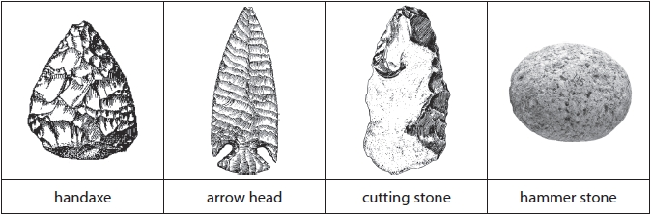
(i) Complete the sentence by putting a cross () in the box next to your answer.
The Stone Age tool made most recently is the
(1)
A handaxe
B arrow head
C cutting stone
D hammer stone
(ii) Suggest how these tools may have helped early humans to survive.
(2)
.............................................................................................................................................
.............................................................................................................................................
.............................................................................................................................................

Q2.The timeline shows when Homo sapiens and some of their ancestors are thought to have inhabited the Earth.
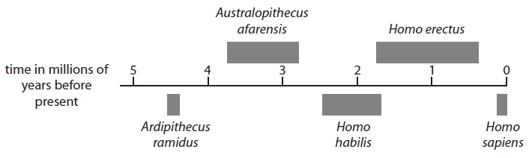
(a) (i) Complete the sentence by putting a cross () in the box next to your answer.
The species which is thought to have inhabited the Earth for the longest period of time is
(1)
A Australopithecus afarensis
B Homo erectus
C Homo habilis
D Homo sapiens

(ii) Estimate the number of years that Homo habilis inhabited the Earth.
(1)
.............................................................................................................................................
(b) Scientists in Africa discovered part of a fossilised skull. The skull was identified as belonging to the species Homo erectus. Describe the methods scientists may have used to identify the skull as belonging to the species Homo erectus.
(2)
.............................................................................................................................................
.............................................................................................................................................
.............................................................................................................................................
Q3. Complete the sentence by putting a cross ( ) in the box next to your answer.
The formation of a new species due to geographical isolation is called
(1)
A adaptation
B competition
C hybridisation
D speciation

Q4. Birds are classified in the domain Eukarya.
(i) Why are the cells from birds described as eukaryotic?
(1)
A they have membrane-bound organelles
B they do not have nuclei
C they have a rigid cell wall
D they have a cell membrane
(ii) Give one reason why the three domain classification system was proposed.
(1)
.............................................................................................................................................
.............................................................................................................................................
.............................................................................................................................................
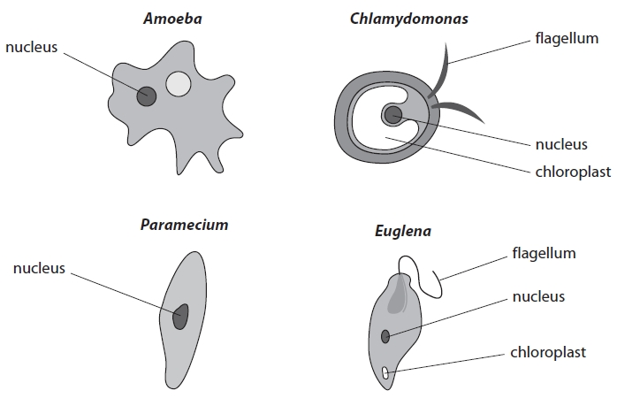
Q5. (a) All the organisms in the diagram belong to one Kingdom.
(i) Which Kingdom do these organisms belong to?
Place a cross () in the box next to your answer.
(1)
A Animalia
B Fungi
C Protoctista
D Prokaryotes
(ii) In which structure are the chromosomes of these organisms found?
Place a cross () in the box next to your answer.
(1)
A cilia
B chloroplast
C flagellum
D nucleus

