Y11 Cycle 1 Week 2 Combined Science Homework: Calculation Questions (Foundation)
Q1.
Calculate the relative formula mass of chromium oxide, Cr₂O₃.
This means 2 atoms of Cr, and 3 atoms of O
(relative atomic masses: O = 16, Cr = 52) (2)
Relative formula mass = (number of atoms of Cr x mass of Cr) + (number of atoms of O x mass of O)
.............................................................................................................................................
.............................................................................................................................................
relative formula mass = ...........................................................
Q2.
Figure 2 gives information about aluminium and tin.
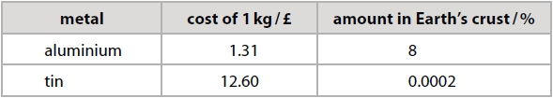 Figure 2
Give two reasons why it could be more important to recycle tin than to recycle aluminium. Use the information in Figure 2. (2)
Reason 1
Which metal is the most expensive to produce, per kilogram?
.............................................................................................................................................
.............................................................................................................................................
Reason 2
Which metal is there least of in the Earth’s crust?
.............................................................................................................................................
.............................................................................................................................................

Q3.
Most copper ores are described as low grade.
This means that the percentage of copper in the ore is very small.
5000 kg of one copper ore was found to contain 42.5 kg of copper.
Calculate the percentage of copper in this ore. (2)
% of copper in the ore = (mass of copper in the ore ÷ mass of the ore) x 100
.............................................................................................................................................
.............................................................................................................................................
.............................................................................................................................................
percentage of copper in ore = ...........................................................

Q4.
Copper sulfate solution was electrolysed for five minutes using copper electrodes.
Figure 5 shows the mass of the anode and of the cathode before electrolysis and after electrolysis.
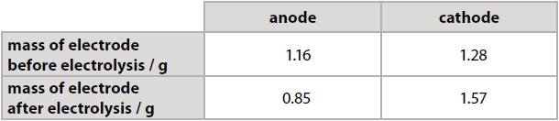 Figure 5
Calculate the mass of copper deposited. (2)
This means that copper was added to the electrode
mass of copper deposited = ........................................................... g
Which electrode increased in mass?
How much did it increase by? (mass after – mass before)
This is the mass of copper deposited

Q5.
1.27 g of copper were produced in an electrolysis experiment.
Calculate the number of moles of copper, Cu, produced in this experiment.
(Relative atomic mass: Cu = 63.5) (1)
Amount in moles = mass of copper ÷ relative atomic mass of copper n = m / A_{r}
..............................................................................................................................................

amount of copper produced = .................................. mol

Q6.
The formula of the iron oxide is Fe₂O₃.
Calculate the maximum mass of iron that can be obtained from 240 tonnes of iron oxide, Fe₂O₃.
(relative atomic masses: O = 16, Fe = 56) (3)
.............................................................................................................................................
 | Fe₂O₃ | Fe
Mass, m | 240 | m_{Fe} = n_{Fe} x M_{r} =
Relative formula mass, M_{r} | M_{r} = (2x56)+(3x16) = ____ | 56
Amount in moles, n = m/M_{r} | n_{Fe2O3} = 240 / ____ | n_{Fe} = 2 x ___ =
Ratio | 1 | 2

.............................................................................................................................................
.............................................................................................................................................
.............................................................................................................................................
.............................................................................................................................................
.............................................................................................................................................
mass of iron = ........................................................... tonnes

Y11 Cycle 1 Week 2 Combined Science Homework (Foundation) - Mark Scheme
Q1.
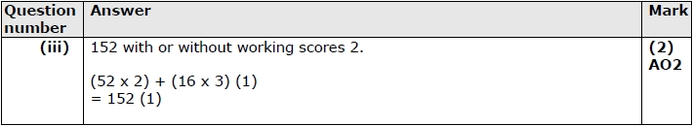
Q2.
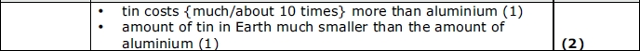
Q3.
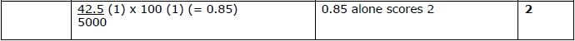
Q4.
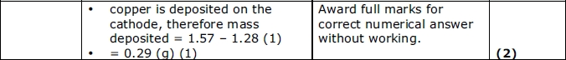
Q5.
 | Answer | Acceptable answers | Mark
(ii) | 1.27 / 63.5 (1) (= 0.02) | 0.02 with no working (1)  correct working with incorrect answer (1) | (1)
Q6.
