Y11 Cycle 1 Week 2 Separate Science Homework – Calculation Questions
Q1.
The female population of Britain is 32.6 million.
The percentage of this population taking the combined contraceptive pill is 13.2%.
The combined pill is 98.8% effective.
Calculate the maximum number of females taking the combined contraceptive pill who could become pregnant. (3)
...........................................................
Q2.
A scientist investigated how the waist to hip ratio affected the probability of developing type 2 diabetes.
The scientist chose 100 females in each of five waist to hip ratio groups and recorded if they developed type 2 diabetes. Figure 6 shows the results.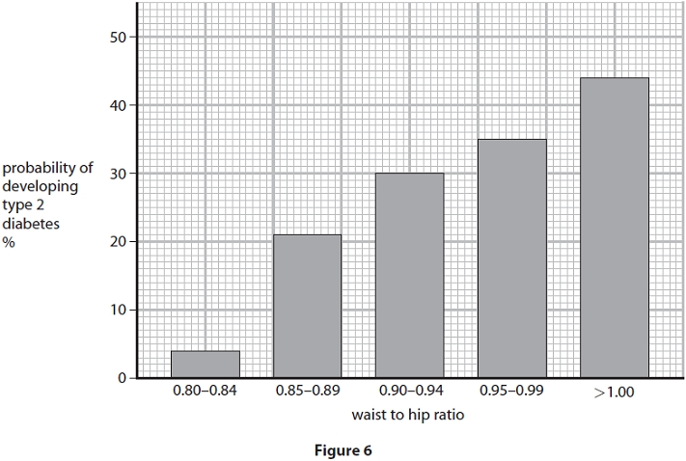Figure 6
(i) Describe the trend shown in Figure 6.
Use data from Figure 6 in your answer.
(2)
.............................................................................................................................................
.............................................................................................................................................
.............................................................................................................................................
(ii) A female has a waist measurement of 78.3 cm and a hip measurement of 90.0 cm.
Calculate the waist to hip ratio for this female and use Figure 6 to estimate the probability that she will develop type 2 diabetes.
(2)
probability ........................................................... %
Q3.
A diabetic athlete is advised to estimate the number of grams of carbohydrate in his meals in order to calculate the number of units of insulin he will need to inject to lower his blood glucose concentration.
Each unit of insulin he injects reduces his blood glucose concentration by 1.5mmol dm^{–3}.
He needs to inject 1 unit for every 10 grams of carbohydrate he consumes.
Figure 12 shows the estimated carbohydrates in the breakfast eaten by the athlete.
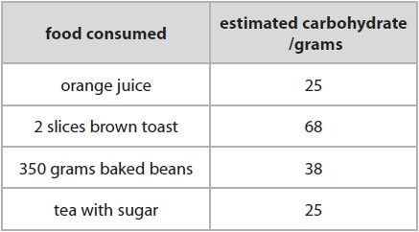 Figure 12
(i) Calculate how many units of insulin the athlete would need to inject to control the rise in blood glucose levels.
Give your answer to two significant figures. (2)
........................................................... units of insulin
(ii) The athlete miscalculated his carbohydrate intake to be greater than his actual intake.
Explain how the increase in the number of units injected would affect his blood glucose concentrations. (2)
.............................................................................................................................................
.............................................................................................................................................
.............................................................................................................................................
.............................................................................................................................................
Q4.
People produce sweat when they are hot. Sweat consists of substances dissolved in water.
Figure 16 shows the concentration of dissolved substances in the sweat of two patients in a hospital.
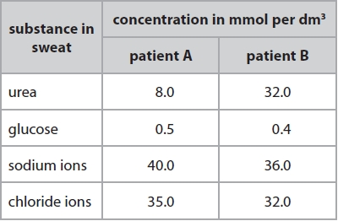 Figure 16
(i) Calculate the ratio of the concentration of urea in the sweat of patient A to the concentration of urea in the sweat of patient B.
Give your answer in its simplest form. (2)
...........................................................
Y11 Cycle 1 Week 2 Separate Science Homework - Mark Scheme
Q1.
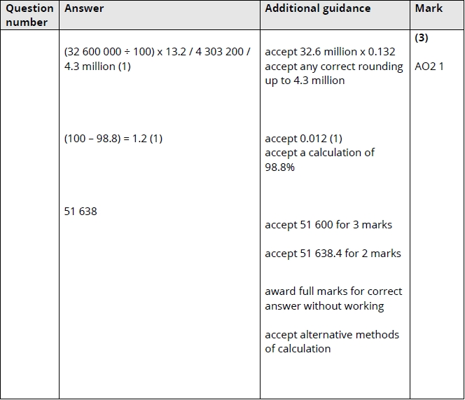
Q2.
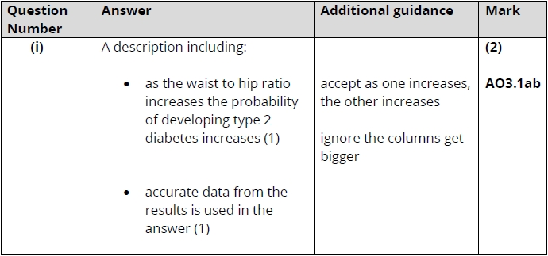
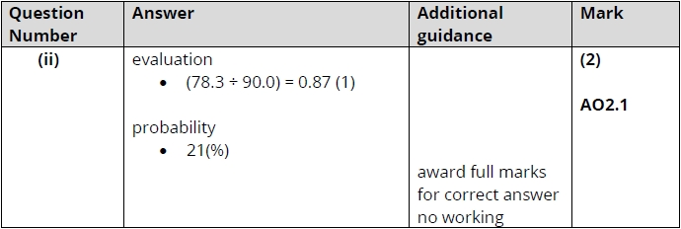

Q3.
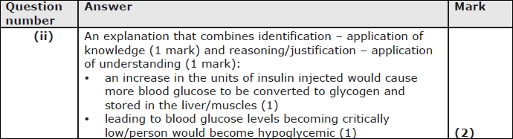

Q4.
