Year 11 Homework
Subject | Religious Education
Cycle | 1 | Week | 3
Hand in Date
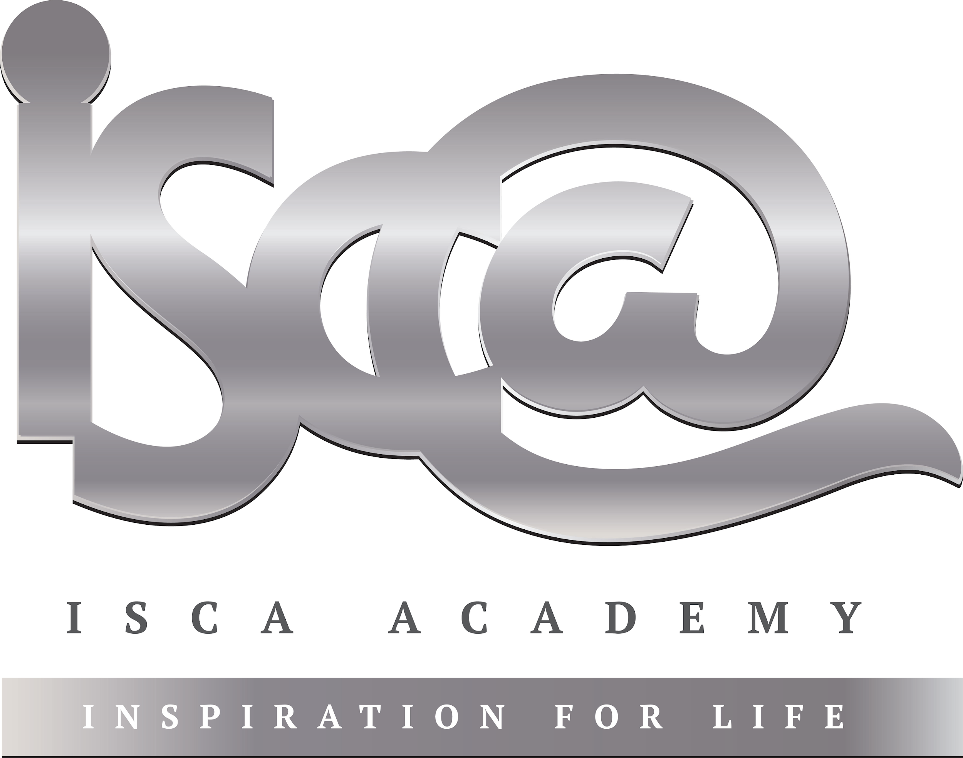
- Each piece of weekly homework is due during your next GCSE RE lesson.
- Support can be gained from:
- Your RE teacher (F33)
- The GCSE revision guide or revision cards, if you have them (if not, they are available on SCOpay)
- The RE ‘AQA’ section of bbc bitesize: https://www.bbc.co.uk/bitesize/examspecs/zjgx47h

Exam Style Questions: 5 Mark Questions = Point / Explain / Point / Explain / Source of Wisdom (give yourself 5 minutes per Q)
If you get any of the following questions wrong, before next week, please ensure you test yourself on your knowledge surrounding the question(s) you got wrong.

- Explain two contrasting religious beliefs about suffering. [5]
__________________________________________________________________________________________________________________________________________________________________________________________________________________________________________________________________________________________________________________________________________________________________________________________________________________________________________________________________________________________________________________________________________

- Explain two Christian attitudes to how God is loving but suffering exists. [5]
__________________________________________________________________________________________________________________________________________________________________________________________________________________________________________________________________________________________________________________________________________________________________________________________________________________________________________________________________________________________________________________________________________

