Y11 Cycle 1 Week 4 Separate Science Homework – Recall Questions
Q1. Figure 13 shows a cross-section of a blood vessel.
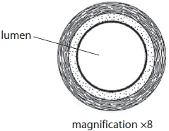
Figure 13
(i) The diameter of the lumen in Figure 13 is 25.0 mm
What is the actual diameter of the lumen of this blood vessel?
(1)
A 3.1 × 10^{–2} m
B 3.1 × 10^{–3} m
C 2.0 × 10^{–2} m
D 2.0 × 10^{–3} m
(ii) Which blood vessel delivers deoxygenated blood to the heart?
(1)
A aorta
B pulmonary artery
C pulmonary vein
D vena cava
(iii) Capillary walls are much thinner than the wall of the blood vessel in Figure 13.
The lumen of a capillary is also much smaller.
Explain how each of these features of the capillary helps it to function efficiently.
(2)
.............................................................................................................................................
.............................................................................................................................................

Q2. Figure 10 shows the estimated blood flow through some parts of the body when a person is at rest and during exercise.
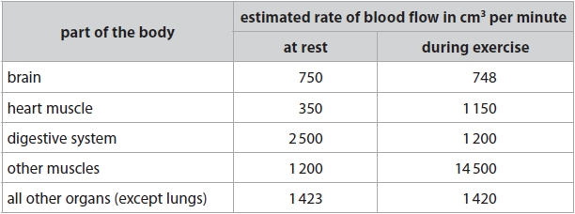
Figure 10

The stroke volume is the amount of blood leaving one chamber of the heart per beat.
From which chamber of the heart does this volume of oxygenated blood flow?
(1)
A left atrium
B left ventricle
C right atrium
D right ventricle
Q3. Answer the question with a cross in the box you think is correct . If you change your mind about an answer, put a line through the box and then mark your new answer with a cross .
(i) Which part of the blood causes blood to start clotting?
(1)
A erythrocytes
B lymphocytes
C platelets
D antibodies
(ii) Give one advantage of a blood clot forming.
(1)
.............................................................................................................................................
.............................................................................................................................................
Q4. (i) Complete the sentence by putting a cross () in the box next to your answer.
A group of the same type of cells, such as red blood cells, is known as
(1)
A an organ
B an organ system
C an organism
D a tissue
(ii) In humans, each mature red blood cell does not have a nucleus.
Suggest why not having a nucleus in a red blood cell is an advantage.
(2)
.............................................................................................................................................
.............................................................................................................................................
.............................................................................................................................................
.............................................................................................................................................

Mark Scheme
Q1.
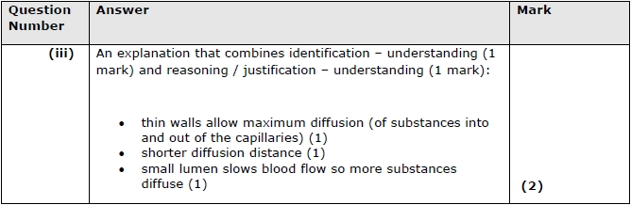

Q2.
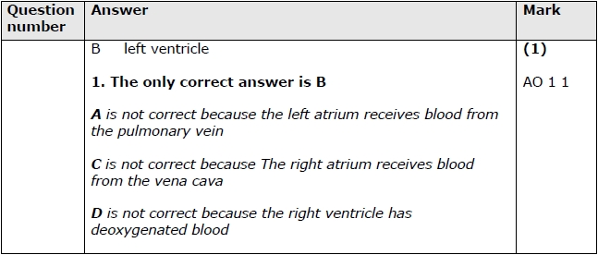

Q3.
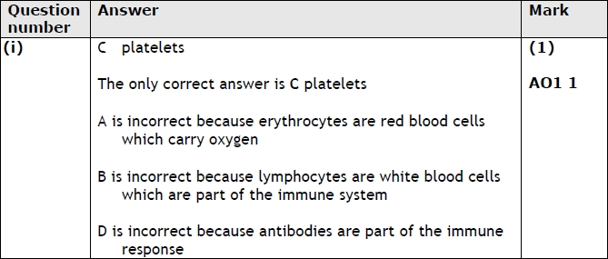
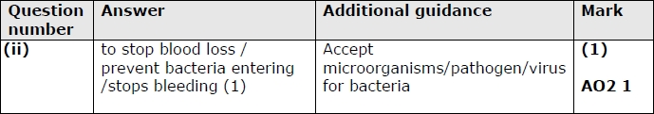

Q4.
