Year 11 Homework
Subject | History
Cycle | 1 | Week | 3
Hand in Date | Week commencing 26/09/22
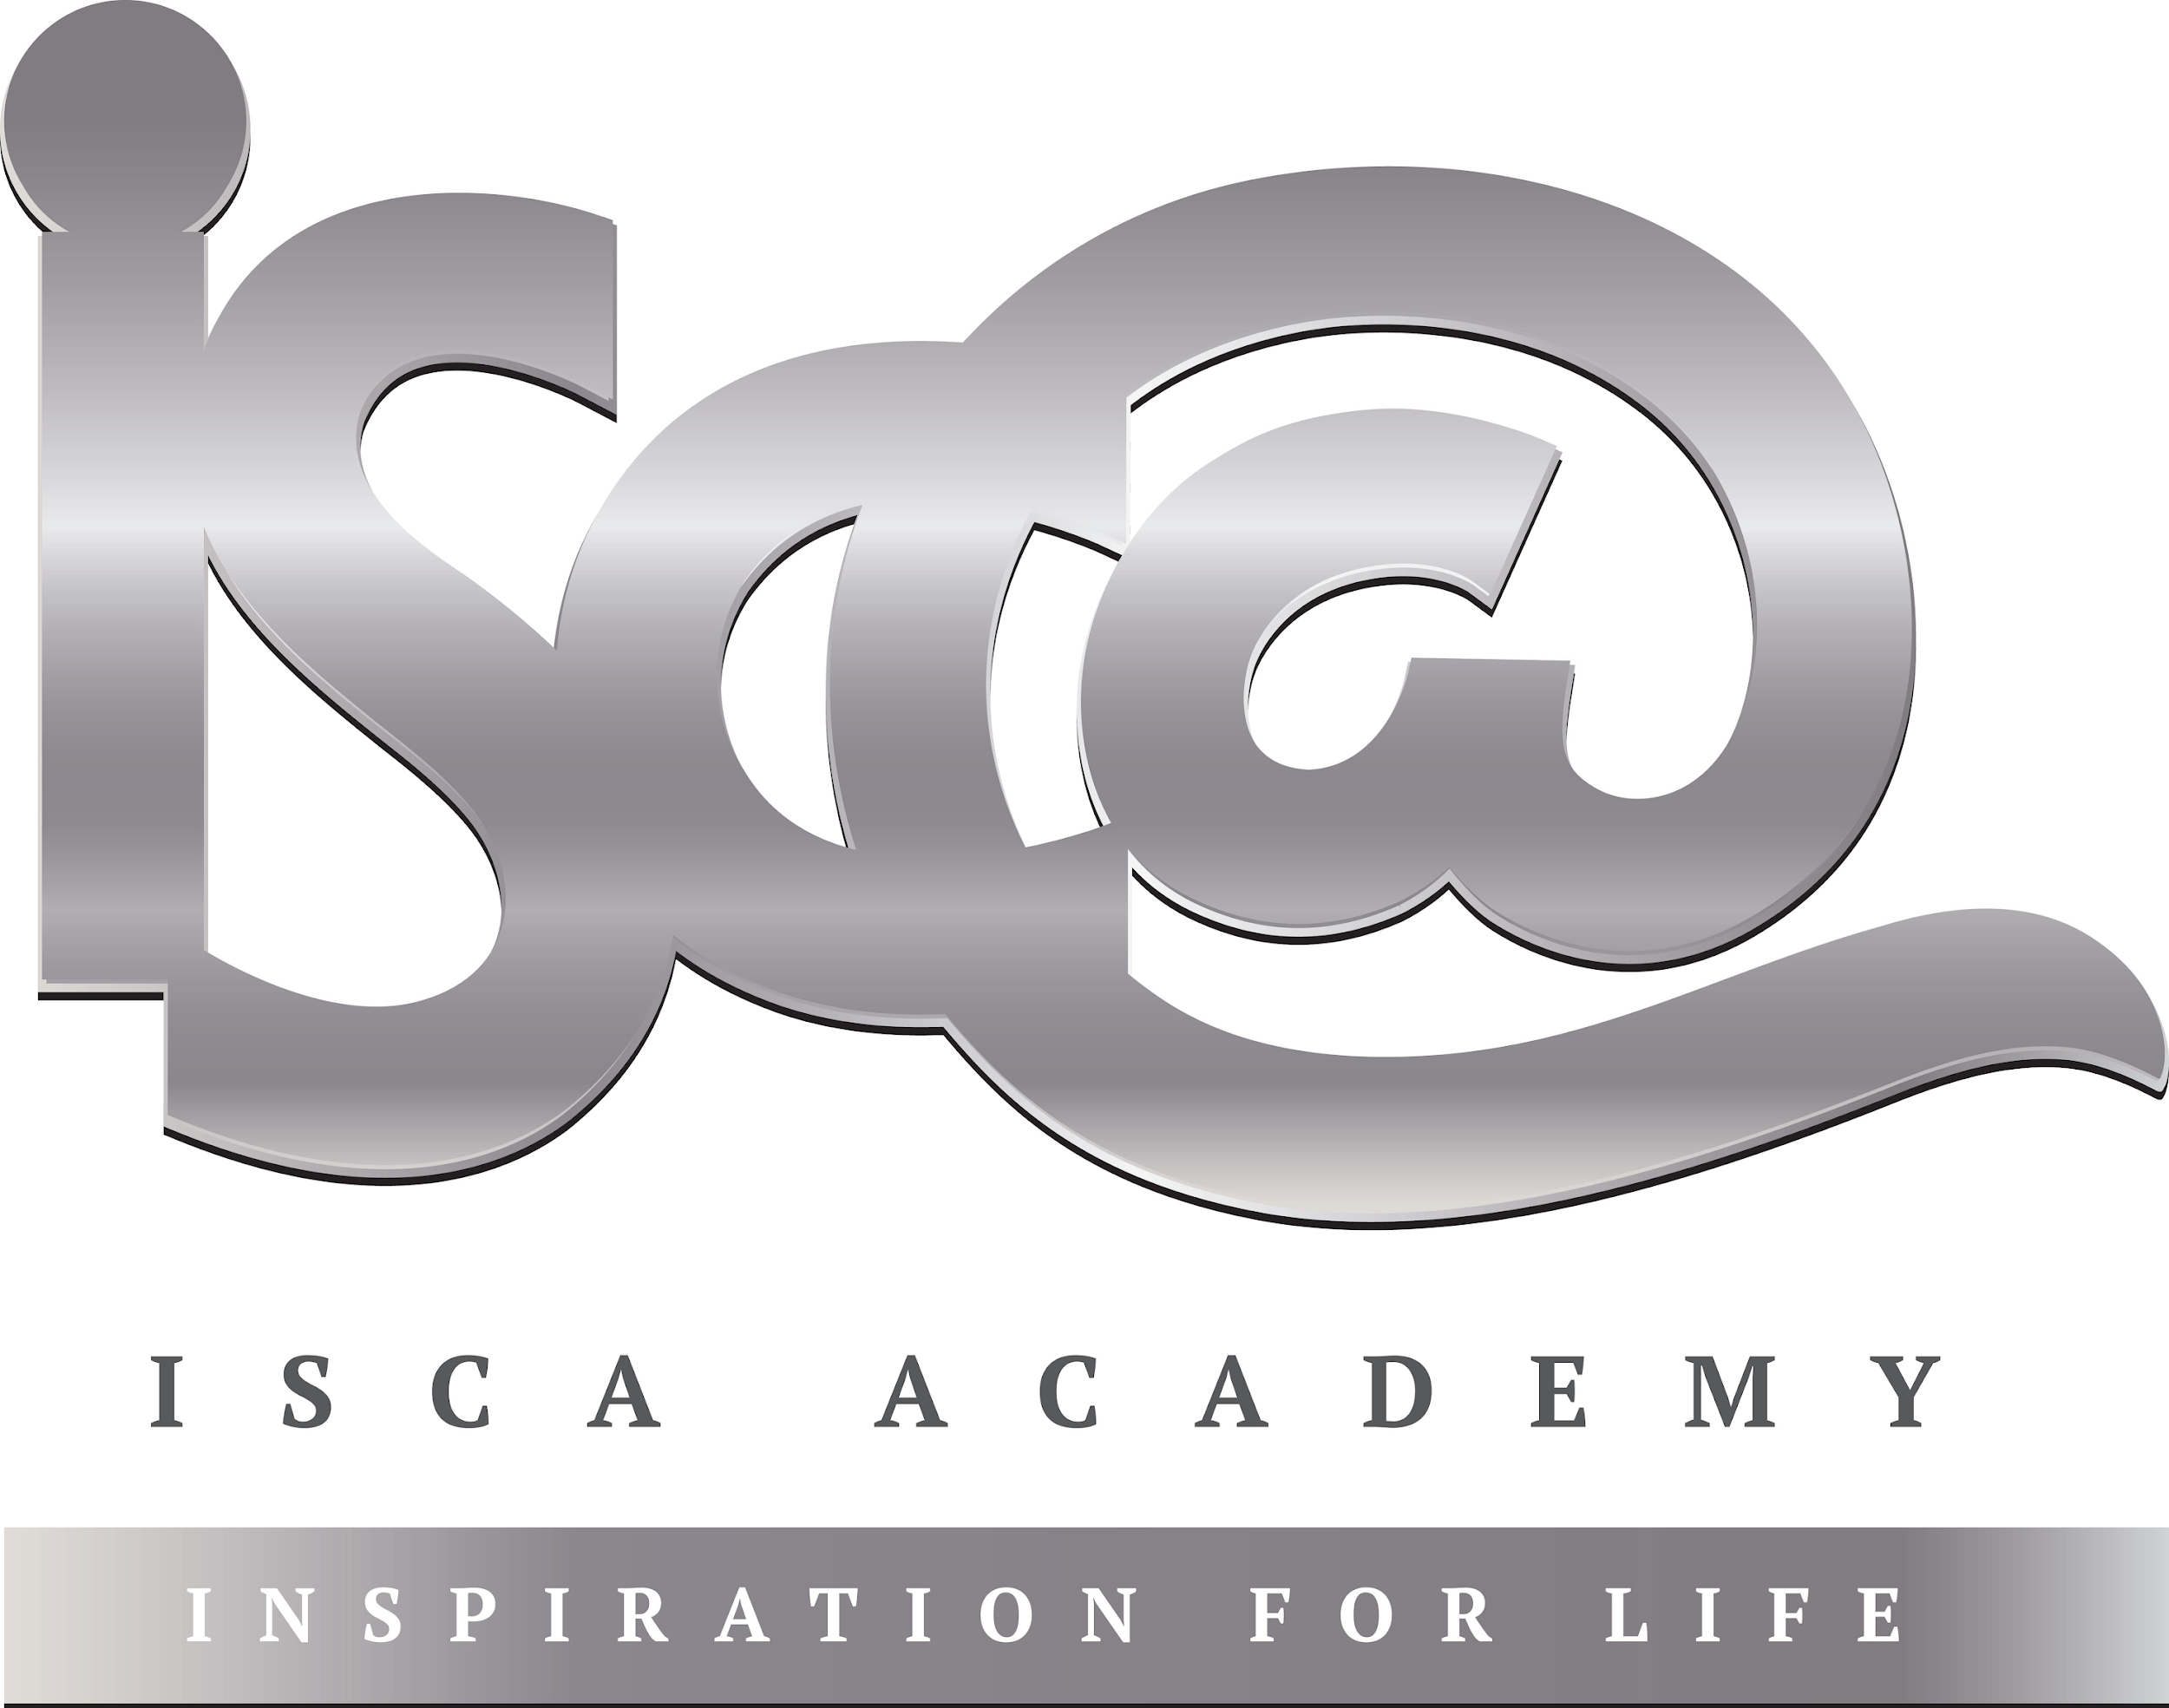
Step 1: Complete the Week 3 Seneca quiz (class code: cx76l0q9h8) – If you don’t yet have a login please speak to your History teacher. Tick the box below to show that you’ve done it and enter the time you’ve spent on this week’s quiz.

Seneca complete □ Time spent:____________________

Step 2: Complete the tasks below:

- Label what you can see happening in the source below.
- Finish the sentence: ‘I must be careful when trusting this source because____________________________
____________________________________________________________________________________________________________________________________________________________________________________________________________________________________________________________________________________
__________________________________________________________________________________________________________________________________________

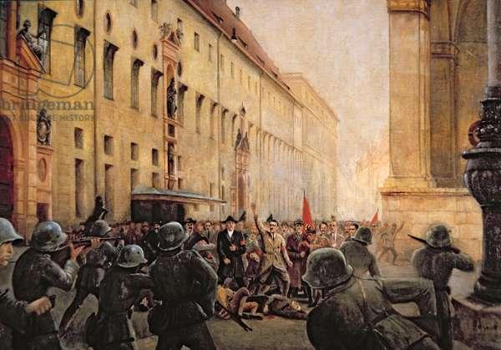
Painting of the end of the Munich Putsch by H Schmitt, 1940

