Year 11 Homework French
Name
Cycle | 1 | Week | 2
Hand in Date

Week 2 Key verbs self-test
to learn
to do / make
to answer
to teach
to read
to get good / bad marks
to revise
to support
to understand
to sit (exam)
to ask
to be absent
to pass (exam)
to fail
to help
to forget
to write
to work
to wear
You should spend time on Quizlet practicing this week’s vocabulary.
It is important to listen to the vocabulary as well as look at it. Practice saying it out loud.

Conjugate CHOISIR in the Present tense:
I choose _____________________________
You choose (s) ________________________
He / she chooses _______________________
We choose ____________________________
You choose (pl) ________________________
They choose __________________________

Strategy: Photo Card

Highlight the theme. What are you talking about? ______________________________________________
- PALMW the first question.

P ____________________________
____________________________
A ___________________________
___________________________
L ____________________________
____________________________
M ___________________________
___________________________
W ___________________________
___________________________

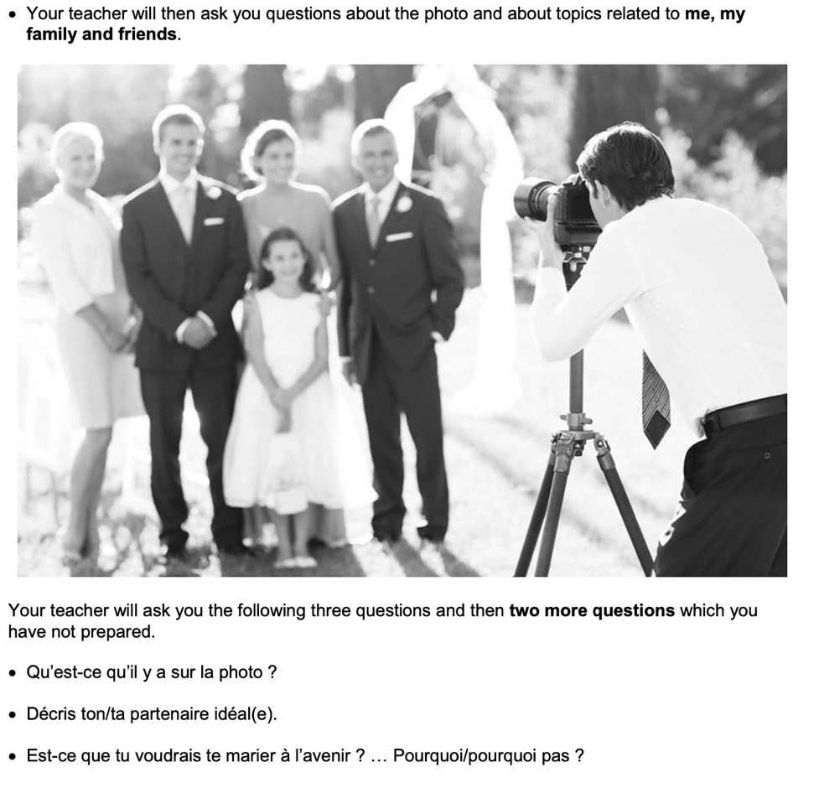
- Draft a response to question 2 in French using 3 sentences.
_________________________________________________________________________________ _________________________________________________________________________________
_________________________________________________________________________________
- Draft a response to question 3 in French using an opinion + justification + 1 more sentence.
_________________________________________________________________________________ _________________________________________________________________________________
_________________________________________________________________________________
- Prepare an answer to this using 1 sentence.
Tu t’entends bien avec ta famille ? ... Pourquoi/pourquoi pas ?
_________________________________________________________________________________
- Prepare an answer to this using 1 sentence.
Qu’est-ce que tu as fait le week-end dernier avec ta famille?
_________________________________________________________________________________

