Year 11 Homework French
Name
Cycle | 1 | Week | 3
Hand in Date

Conjugate APPRENDRE in the Perfect tense:
I learnt _______________________________
You learnt (s) __________________________
He/she learnt _________________________
We learnt ____________________________
You learnt ____________________________
They learnt ___________________________

You should spend time on Quizlet practicing this week’s vocabulary.
It is important to listen to the vocabulary as well as look at it. Practice saying it out loud.

Week 3 – Opinions self-test
I think that
in my opinion
the bad thing
too much, too many
the good thing
a lot, much, many
quite, a few, enough, quite a bit
It seems to me that
I would say that
little, not much, few
I believe that
as for

Strategy: Role Play
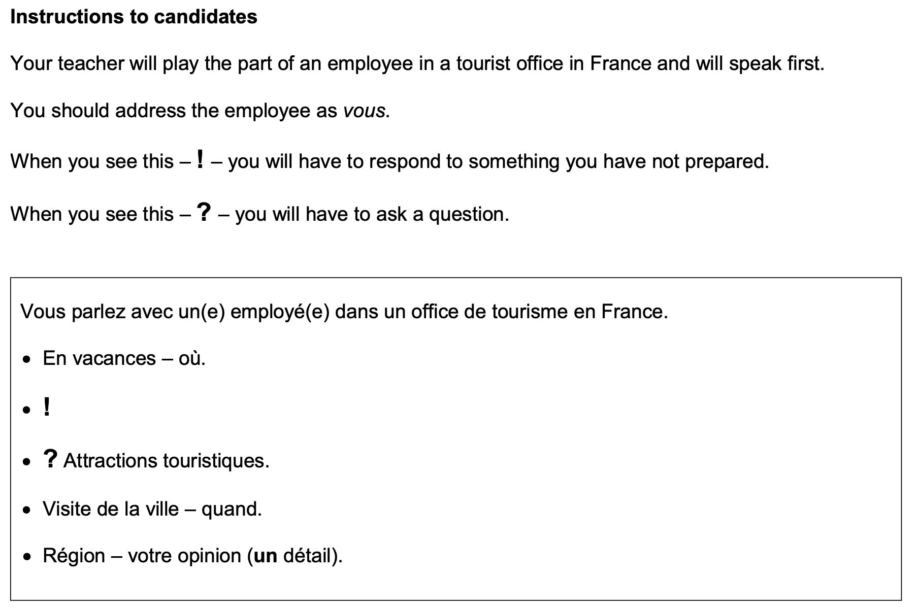
Et vous restez combien de temps ?

- Highlight the context. Where are you? Who are you talking to?

______________________________________________________________________________

- Translate the bullets into English (do this above).

- Draft a response in French using FULL sentences each time.

- ____________________________________________________________________________________________________________________________________________________________
- ______________________________________________________________________________
______________________________________________________________________________
- ____________________________________________________________________________________________________________________________________________________________
- ____________________________________________________________________________________________________________________________________________________________
- ______________________________________________________________________________
_____________________________________________________________________________________

