Year 11 Homework French
Name
Cycle | 1 | Week | 4
Hand in Date

Conjugate ALLER in the Perfect tense:
I went _______________________________
You went (s) __________________________
He/she went __________________________
We went _____________________________
You went (pl) _________________________
They went ____________________________
You should spend time on Quizlet practicing this week’s vocabulary.
It is important to listen to the vocabulary as well as look at it. Practice saying it out loud.

Week 4 – Can, must, have to self-test
You can…
We can…
We need to…
We have to…
The expressions above can be followed by an infinitive to say what you must, can or have to do.
bring equipment
do homework
arrive on time
wear uniform
respect others
help your friends
revise
be polite

Strategy: Photo Card
Highlight the theme. What are you talking about? ______________________________________________

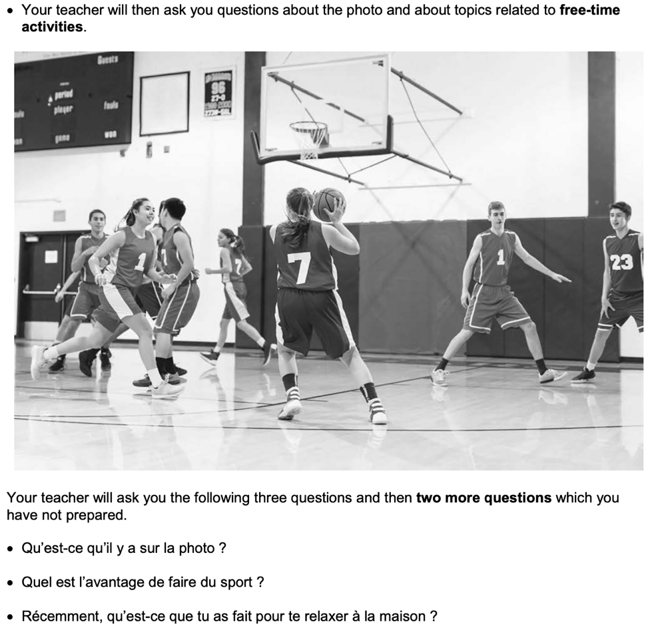
- PALMW the first question.

P ____________________________
____________________________
A ___________________________
___________________________
L ____________________________
____________________________
M ___________________________
___________________________
W ___________________________
___________________________

- Draft a response to question 2 in French using an opinion + justification + 1 more sentence.
____________________________________________________________________________________ ____________________________________________________________________________________
____________________________________________________________________________________
- Draft a response to question 3 in French using 3 sentences.
____________________________________________________________________________________ ____________________________________________________________________________________
____________________________________________________________________________________
- Prepare an answer to this using 1 sentence.
Est-ce que tu aimes aller au cinéma ? ... Pourquoi/pourquoi pas ?
____________________________________________________________________________________
- Prepare an answer to this using 1 sentence.
Qu’est-ce que tu vas faire avec tes amis ce week-end?
____________________________________________________________________________________________

