Year 11 Homework Spanish
Name
Cycle | 1 | Week | 2
Hand in Date

Week 2 Key verbs self-test
to learn
to do / make
to answer
to teach
to take part
to get good / bad marks
to revise
to support
to understand
to listen
to ask
to be absent
to pass (exam)
to look
to help
to forget
to write
to work
to wear
You should spend time on Quizlet practicing this week’s vocabulary.
It is important to listen to the vocabulary as well as look at it. Practice saying it out loud.

Conjugate REPASAR in the Present Continuous:
I am revising __________________________
You are revising (s) _____________________
He / she is revising _____________________
We are revising ________________________
You are revising (pl) ____________________
They are revising _______________________

Strategy: Photo Card

Highlight the theme. What are you talking about? ______________________________________________

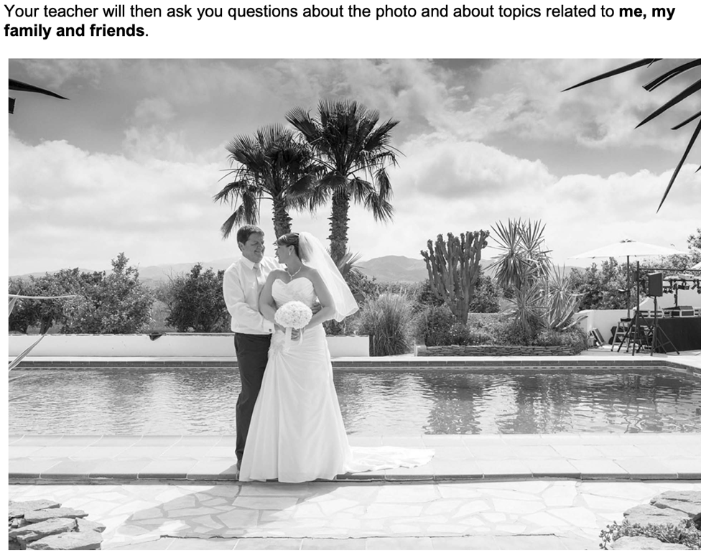
- PALMW the first question.

P ____________________________
____________________________
A ___________________________
___________________________
L ____________________________
____________________________
M ___________________________
___________________________
W ___________________________
___________________________

- Draft a response to question 2 in Spanish using an opinion + justification + 1 more sentence.
_________________________________________________________________________________ _________________________________________________________________________________
_________________________________________________________________________________
- Draft a response to question 3 in Spanish using 3 sentences.
_________________________________________________________________________________ _________________________________________________________________________________
_________________________________________________________________________________
- Prepare an answer to this using 1 sentence.
¿Prefieres pasar tiempo con tu familia o con tus amigos? ... ¿Por qué?
_________________________________________________________________________________
- Prepare an answer to this using 1 sentence.
¿Qué hiciste con tu familia durante las vacaciones de Navidad?
_________________________________________________________________________________

