Year 11 Homework Spanish
Name
Cycle | 1 | Week | 3
Hand in Date

Conjugate APRENDER in the Preterite tense:
I learnt _______________________________
You learnt (s) __________________________
He/she learnt _________________________
We learnt ____________________________
You learnt ____________________________
They learnt ___________________________

You should spend time on Quizlet practicing this week’s vocabulary.
It is important to listen to the vocabulary as well as look at it. Practice saying it out loud.

Week 3 – Opinions self-test
I think that
the bad thing
from my point of view
I hate (x2)
too much, too many
the good thing
I like
a lot, much, many
I have to say
quite, a few, enough, quite a bit
I prefer
It seems to me
I would say that
I don’t like
little, not much, few
I believe that
as for

Strategy: Role Play
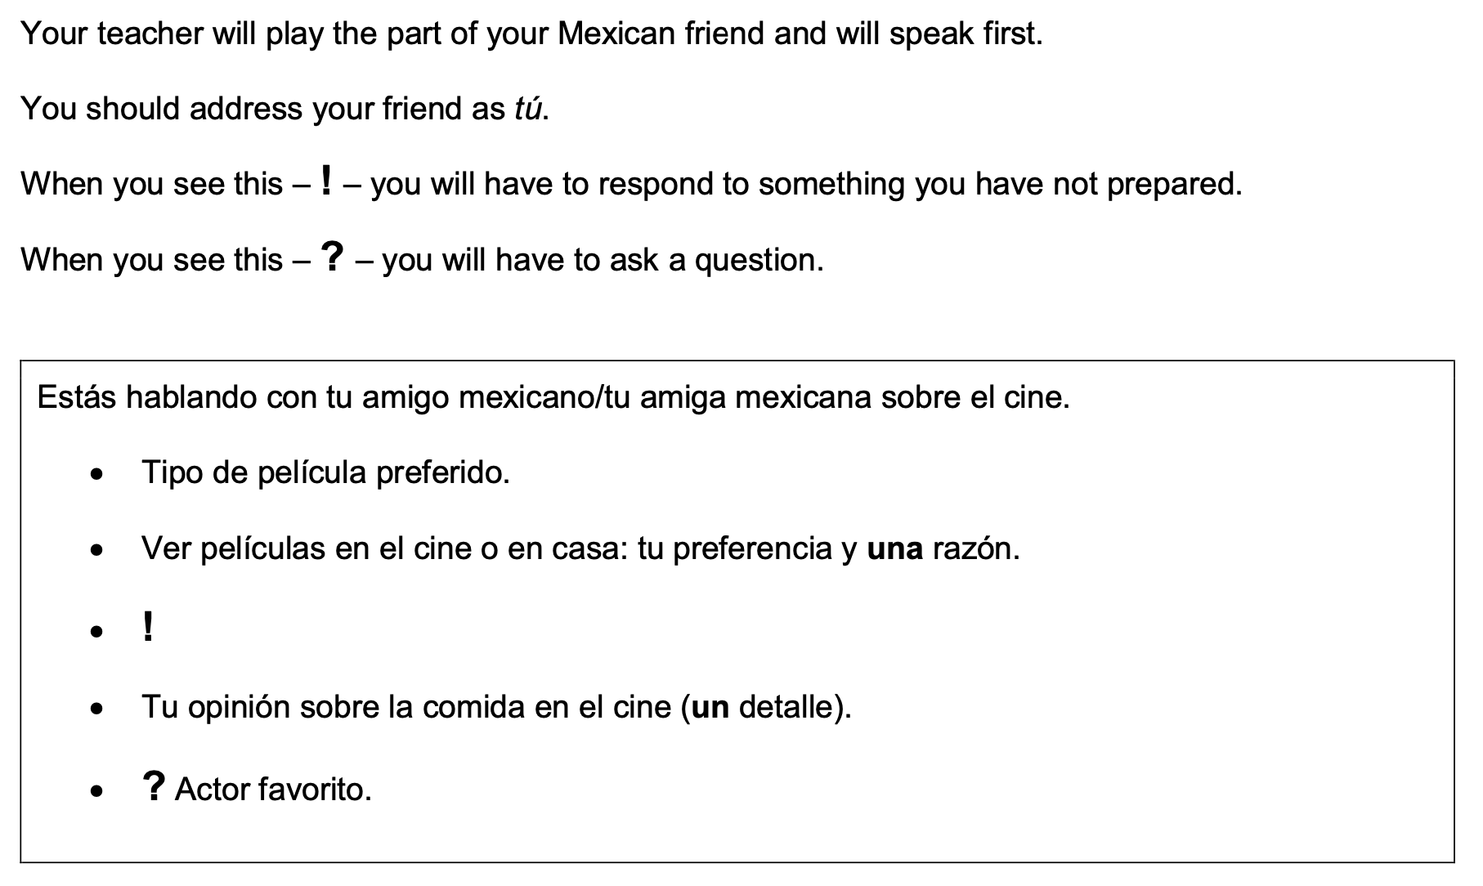
Normalmente, ¿cuándo vas al cine?

- Highlight the context. Where are you? Who are you talking to?

______________________________________________________________________________

- Translate the bullets into English (do this above).

- Draft a response in Spanish using FULL sentences each time.

- ____________________________________________________________________________________________________________________________________________________________
- ______________________________________________________________________________
______________________________________________________________________________
- ____________________________________________________________________________________________________________________________________________________________
- ____________________________________________________________________________________________________________________________________________________________
- ______________________________________________________________________________
_____________________________________________________________________________________

