Year 11 Homework Spanish
Name
Cycle | 1 | Week | 4
Hand in Date

Conjugate ESCUCHAR in the Perfect tense:
I have listened _________________________
You have listened (s) ____________________
He/she has listened ____________________
We have listened ______________________
You have listened (pl) ___________________
They have listened _____________________
You should spend time on Quizlet practicing this week’s vocabulary.
It is important to listen to the vocabulary as well as look at it. Practice saying it out loud.

Week 4 – Can, must, have to self-test
You can…
I have to…
You must…
You have to…
The expressions above can be followed by an infinitive to say what you must, can or have to do.
bring equipment
do homework
arrive on time
wear uniform
show respect
support your friends
go to lessons

Strategy: Photo Card

Highlight the theme. What are you talking about? ______________________________________________
- PALMW the first question.

P ____________________________
____________________________
A ___________________________
___________________________
L ____________________________
____________________________
M ___________________________
___________________________
W ___________________________
___________________________

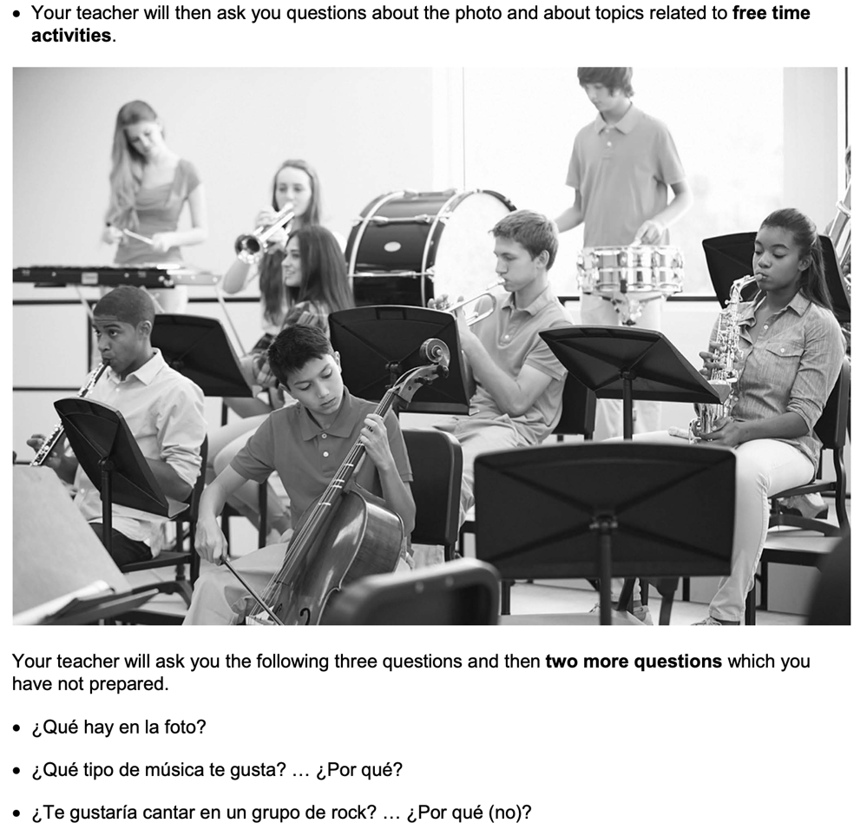

- Draft a response to question 2 in Spanish using an opinion + justification + 1 more sentence.
____________________________________________________________________________________ ____________________________________________________________________________________
____________________________________________________________________________________
- Draft a response to question 3 in Spanish using 3 sentences.
____________________________________________________________________________________ ____________________________________________________________________________________
____________________________________________________________________________________
- Prepare an answer to this using 1 sentence.
Háblame de tu programa de televisión favorito.
____________________________________________________________________________________
- Prepare an answer to this using 1 sentence.
¿Qué hiciste la última vez que saliste con tus amigos?
____________________________________________________________________________________________

