Y11 Cycle 1 Week 3 Combined Science Homework: Extended writing questions (Foundation)
Q1.
(a) Complete the sentence by putting a cross ( ) in the box next to your answer.
Sperm cells and egg cells contain sex chromosomes.
Egg cells contain
(1)
A one X chromosome
B one Y chromosome
C two X chromosomes
D two Y chromosomes

(b) (i) Complete the Punnett square to show how the sex of a child is inherited.
(2)
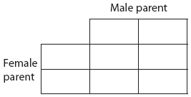

(ii) Calculate the percentage chance that a child will be female.
(1)
..............................................................................................................................................

(c) The diagram shows the level of two hormones involved in the menstrual cycle and the thickness of the uterus lining.

Using the information in the diagram and your own knowledge, describe the stages of the menstrual cycle.
(6)
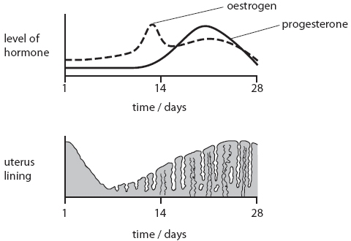

..............................................................................................................................................
If you’re stuck try searching for this video on youtube ‘GCSE Biology The Menstrual Cycle (Foundation) Edexcel 9-1’

Hint: Look at the graphs on the previous page. Say what is happening to the hormone and then what is happening to the lining of the uterus

On day one of the menstrual cycle the …..
Key words
Menstruation Uterus lining
Ovulation Ovum
Maintained Thickened
Increases Decreases

..............................................................................................................................................
..............................................................................................................................................
..............................................................................................................................................
..............................................................................................................................................
..............................................................................................................................................
..............................................................................................................................................
..............................................................................................................................................
..............................................................................................................................................
..............................................................................................................................................
..............................................................................................................................................
..............................................................................................................................................
..............................................................................................................................................
..............................................................................................................................................
..............................................................................................................................................
..............................................................................................................................................
..............................................................................................................................................
..............................................................................................................................................
..............................................................................................................................................
..............................................................................................................................................
..............................................................................................................................................
..............................................................................................................................................

(d) Explain what happens to the uterus lining if a woman becomes pregnant.
(2)
..............................................................................................................................................
..............................................................................................................................................
..............................................................................................................................................
..............................................................................................................................................
(Total for Question = 12 marks)

