Y11 Cycle 1 Week 3 Combined Science Homework: Extended writing questions (Higher)

Q1.
The combined contraceptive pill contains the hormones oestrogen and progesterone.
(i) State the endocrine gland that releases oestrogen.
(1)
.............................................................................................................................................

(ii) Explain how high levels of oestrogen and progesterone in the combined contraceptive pill work together to prevent pregnancy.
(4)
.............................................................................................................................................
.............................................................................................................................................
.............................................................................................................................................
.............................................................................................................................................
.............................................................................................................................................
.............................................................................................................................................
.............................................................................................................................................
.............................................................................................................................................
.............................................................................................................................................

(Total for question = 5 marks)

Q2.
* Explain how hormones control the menstrual cycle.
TIPS
Name all 4 hormones involved
State where each hormone is produced
Explain what effect each hormone has on specific parts of the menstrual cycle, including inhibition

(6)

.............................................................................................................................................
.............................................................................................................................................
.............................................................................................................................................
.............................................................................................................................................
.............................................................................................................................................
.............................................................................................................................................
.............................................................................................................................................
.............................................................................................................................................
.............................................................................................................................................
.............................................................................................................................................
.............................................................................................................................................
.............................................................................................................................................
.............................................................................................................................................
.............................................................................................................................................
.............................................................................................................................................
.............................................................................................................................................
.............................................................................................................................................
.............................................................................................................................................

(Total for question = 6 marks)

Mark Scheme
Q1.
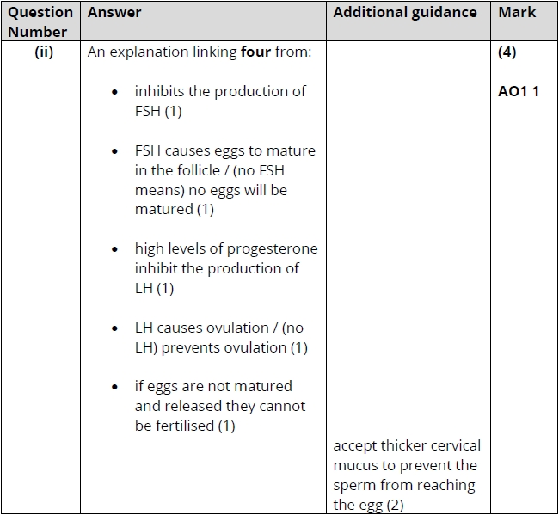

Q2.
