Year 11 Homework Computer Science
Name
Cycle | 1 | Week | 5
Hand in Date

Please state the 3 programming techniques  ____________________________  ____________________________  ____________________________  Algorithmic Thinking is one of the components of computational thinking. State the other two. They begin with A and D.  A……………………..….  D…………………………  How many rows would there be in this truth table?  _______________  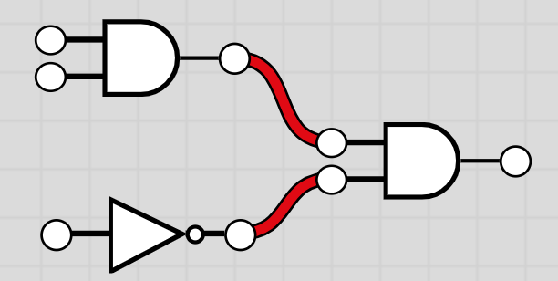  What gate has not been used in this circuit?  ___________  What would be output if  1  1  1  inputted into this logic circuit?  _______________________________ | What does DNS stand for and what does it  do? …………………..…………………………  ………………………………………………….  Describe the primary function of the ALU  ………………………………………………….  Why can’t lossy compression be used on text files?  ………………………………………………….……………………………………………………………………………………………………………………………………………………….
