Year 11 Homework Computer Science
Name
Cycle | 1 | Week | 6
Hand in Date

Please answer 20 smart quiz questions on Smart Revise - they have been set as a homework task.

Programming Writing  Write a for loop which  inputs 2 numbers  multiples them  Repeats this until the result is greater than 100  State the four data types and what is stored in each one | Programming Reading  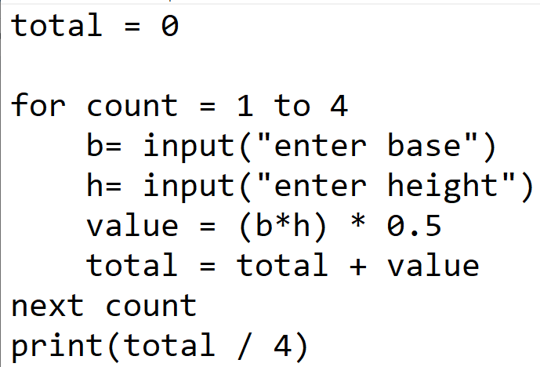  Complete the trace table with the following values. (I have started you off on the first 2)  10,20,8,6,16,12,15,40  Total b h value output  0 10 20
