Year 11 Homework
Subject | Religious Education
Cycle | 1 | Week | 5
Hand in Date
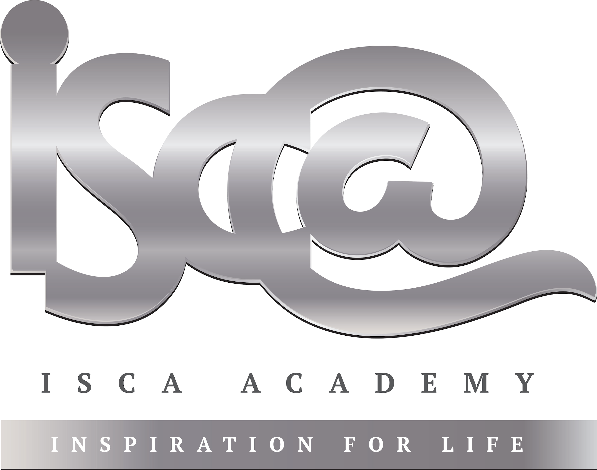
- Each piece of weekly homework is due during your next GCSE RE lesson.
- Support can be gained from:
- Your RE teacher (F33)
- The GCSE revision guide or revision cards, if you have them (if not, they are available on SCOpay)
- The RE ‘AQA’ section of bbc bitesize: https://www.bbc.co.uk/bitesize/examspecs/zjgx47h

Answer the following questions. You will then peer mark in your next lesson.

- Give two quotes from Christianity that teach about forgiveness:

A._____________________________________________________________________________

B. ____________________________________________________________________________

- What prayer teaches Christians that forgiveness is important?

___________________________________________________________

- For Buddhists, why is forgiveness important? Give two reasons:

A._____________________________________________________________________________

B. ____________________________________________________________________________

- Finish the Buddhist quote… ‘He abused me, he struck me, he overcame me……’

__________________________________________________________________________
- Is forgiveness a replacement for punishment, according to Buddhists and Christians?

Yes / No

