Year 11 Homework
Subject | Religious Education
Cycle | 1 | Week | 6
Hand in Date
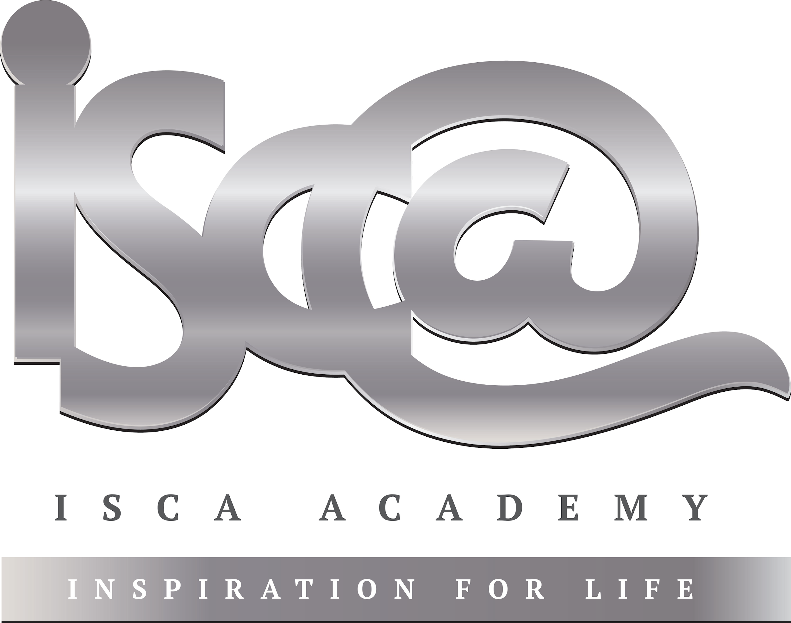
- Each piece of weekly homework is due during your next GCSE RE lesson.
- Support can be gained from:
- Your RE teacher (F33)
- The GCSE revision guide or revision cards, if you have them (if not, they are available on SCOpay)
- The RE ‘AQA’ section of bbc bitesize: https://www.bbc.co.uk/bitesize/examspecs/zjgx47h

Exam Style Questions: 1 Mark Questions = Multiple Choice (give yourself 1 minute per Q)
If you get any of the following questions wrong, before next week, please ensure you test yourself on your keywords.

Which one of the following is another word for the ‘death penalty’? [1]
- Corporal Punishment
- Prison
- Capital Punishment
- Retribution

Which one of the following terms means to inflict physical pain on someone? [1]
- Corporal Punishment
- Capital Punishment
- Prison
- Community Service

Which one of the following means revenge? [1]
- Capital Punishment
- Reparation
- Protection
- Reformation

Which one of the following means to make someone better? [1]
- Capital Punishment
- Reparation
- Protection
- Reformation

