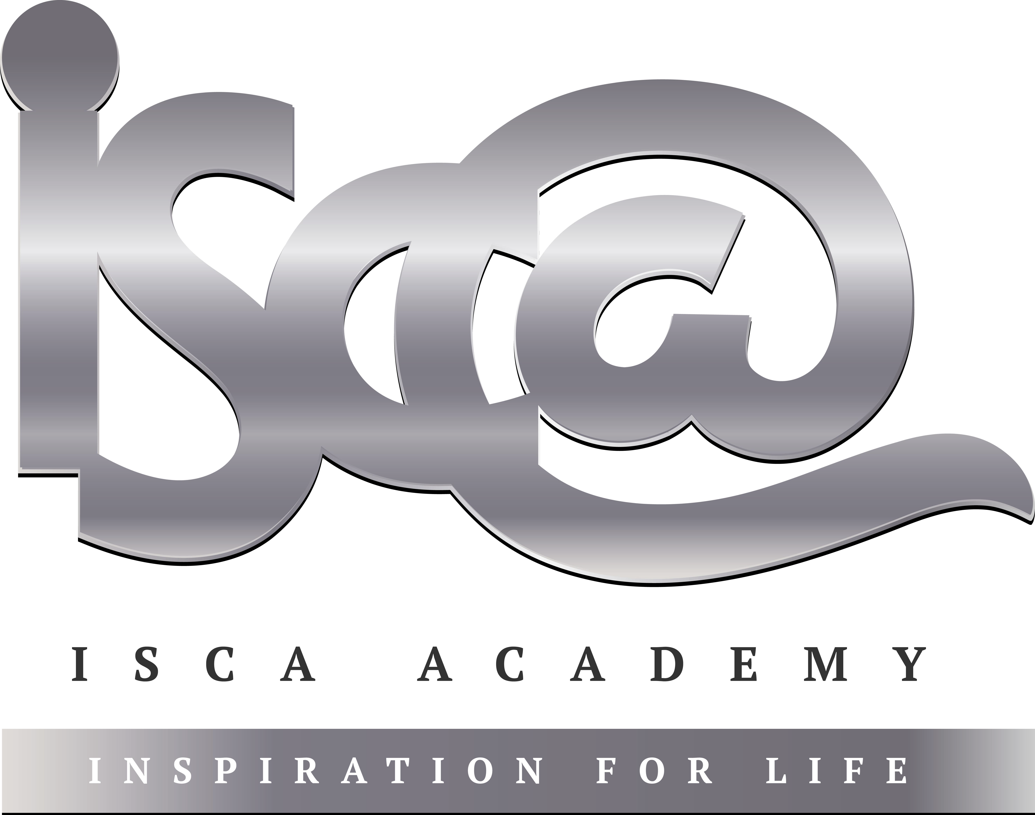
Year 11 Homework French
Name
Cycle | 1 | Week | 5
Hand in Date

Conjugate Être in the Conditional tense:
I would be ____________________________
You would be (s) _______________________
He/she would be _______________________
We would be __________________________
You would be (pl) ______________________
They would be_________________________

You should spend time on Quizlet practicing this week’s vocabulary.
It is important to listen to the vocabulary as well as look at it. Practice saying it out loud.

Week 5 Future phrases self-test
I would like (vouloir)
I am going to
I want
next year
I could
I should
He / she would like
You would like (s)
We would like
I would like
They would like
in the future
You would like (pl)
I would go
I would do

Strategy: Role Play
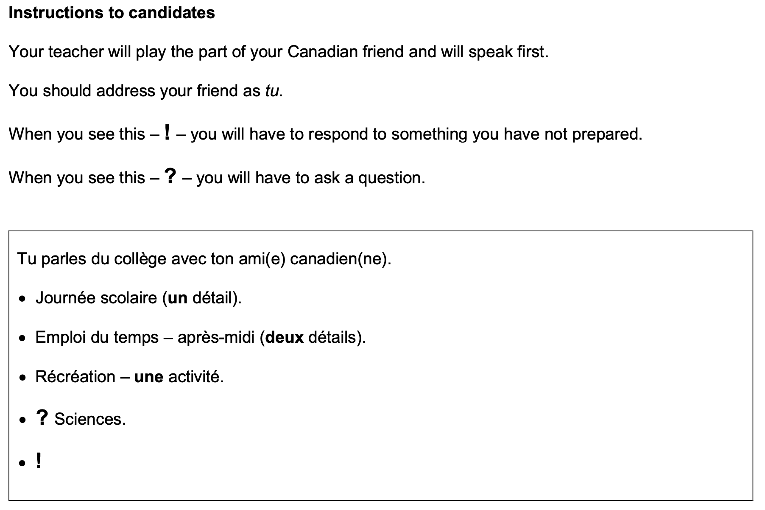
Que penses-tu de l’uniforme scolaire?

- Highlight the context. Where are you? Who are you talking to?

______________________________________________________________________________

- Translate the bullets into English (do this above).

- Draft a response in French using FULL sentences each time.

- ____________________________________________________________________________________________________________________________________________________________
- ______________________________________________________________________________
______________________________________________________________________________
- ____________________________________________________________________________________________________________________________________________________________
- ____________________________________________________________________________________________________________________________________________________________
- ______________________________________________________________________________
_____________________________________________________________________________________

