Year 11 Homework French
Name
Cycle | 1 | Week | 6
Hand in Date

Conjugate FAIRE in the Immediate Future:
I am going to do _______________________
You are going to do (s) __________________
He/she is going to do ___________________
We are going to do _____________________
You are going to do (pl) _________________
They are going to do ____________________
You should spend time on Quizlet practicing this week’s vocabulary.
It is important to listen to the vocabulary as well as look at it. Practice saying it out loud.

Week 6 Immediate Future
To get, obtain
We are going
To hope
They’re going
To dream
To travel
You are going (pl)
To earn, win
To be unemployed
To work
I am going
He / she is going
To find
You’re going (s)
To get, receive
To drop

Strategy: Photo Card

Highlight the theme. What are you talking about? ______________________________________________

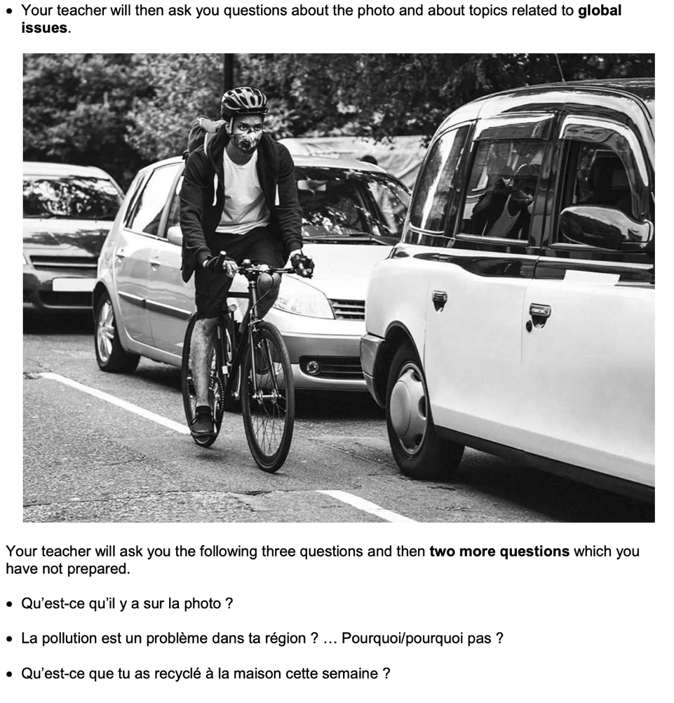
- PALMW the first question.

P ____________________________
____________________________
A ___________________________
___________________________
L ____________________________
____________________________
M ___________________________
___________________________
W ___________________________
___________________________

- Draft a response to question 2 in French using an opinion + justification + 1 more sentence.
____________________________________________________________________________________ ____________________________________________________________________________________
____________________________________________________________________________________
- Draft a response to question 3 in French using 3 sentences.
____________________________________________________________________________________ ____________________________________________________________________________________
____________________________________________________________________________________
- Prepare an answer to this using 1 sentence.
Qu’est-ce que tu feras la semaine prochaine pour aider l’environnement ?
____________________________________________________________________________________
- Prepare an answer to this using 1 sentence.
A ton avis les pistes cyclables sont une bonne idée? Pourquoi / porquoi pas?
____________________________________________________________________________________________

