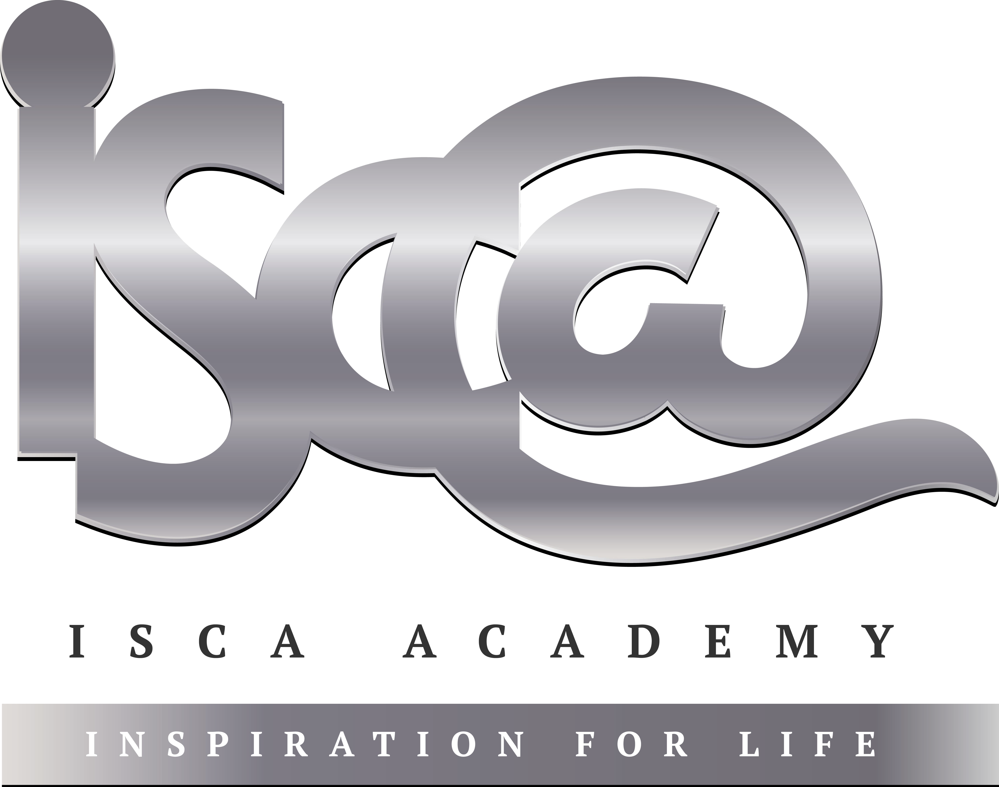
Year 11 Homework Spanish
Name
Cycle | 1 | Week | 5
Hand in Date

Conjugate SER in the Conditional tense:
I would be ____________________________
You would be (s) _______________________
He/she would be _______________________
We would be __________________________
You would be (pl) ______________________
They would be_________________________

You should spend time on Quizlet practicing this week’s vocabulary.
It is important to listen to the vocabulary as well as look at it. Practice saying it out loud.

Week 5 Future phrases self-test
I would like x 1
I would like x 2
I am going to
I want
Conditional tense
I could
I should
He / she would go
You would go (s)
We would go
I would go
They would go
You would go (pl)
next month
in the future
next year

Strategy: Role Play
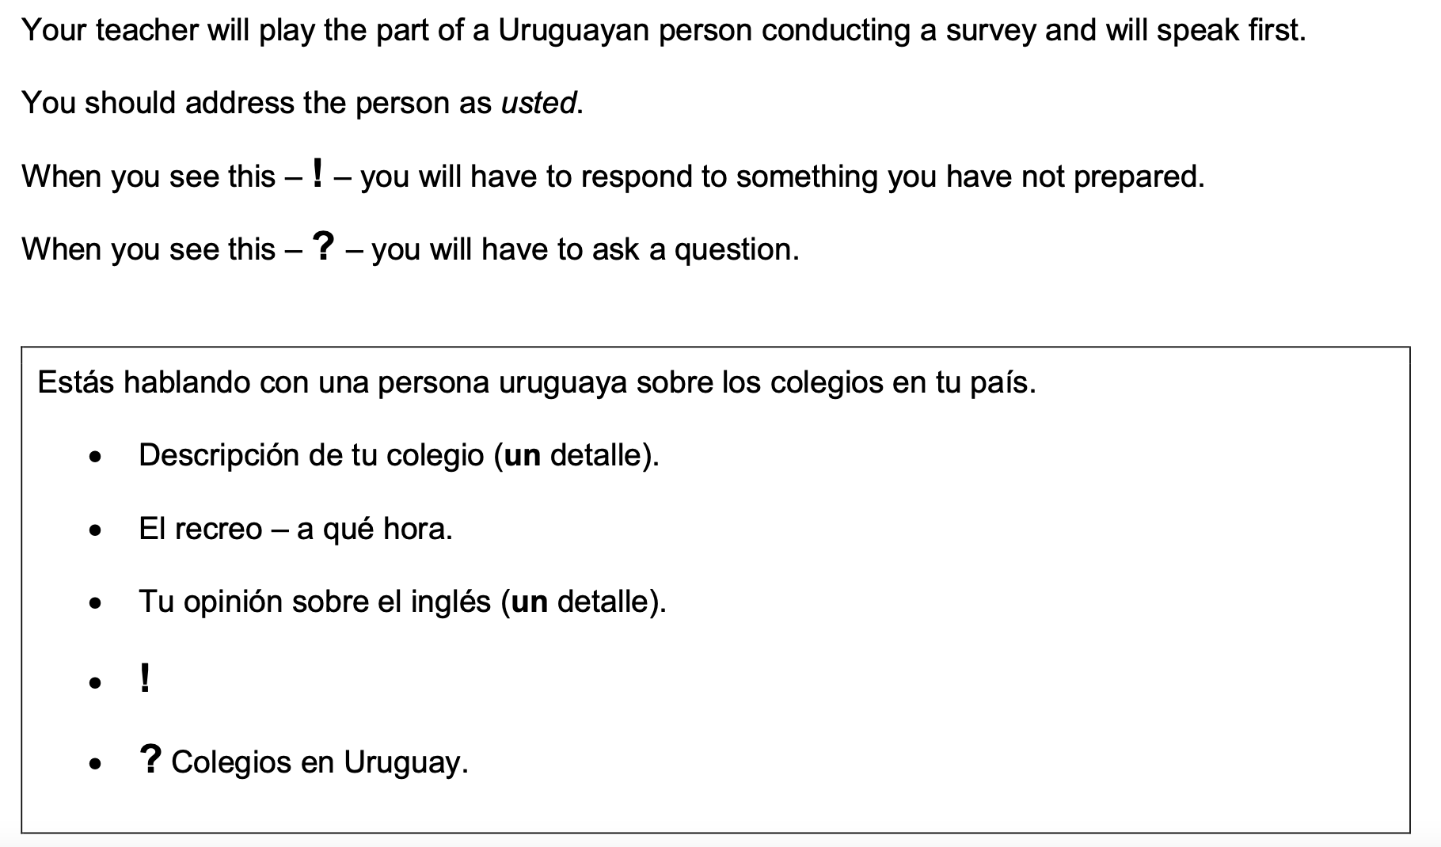
¿Cuántas clases de ciencias tiene a la semana?

- Highlight the context. Where are you? Who are you talking to?

______________________________________________________________________________

- Translate the bullets into English (do this above).

- Draft a response in Spanish using FULL sentences each time.

- ____________________________________________________________________________________________________________________________________________________________
- ______________________________________________________________________________
______________________________________________________________________________
- ____________________________________________________________________________________________________________________________________________________________
- ____________________________________________________________________________________________________________________________________________________________
- ______________________________________________________________________________
_____________________________________________________________________________________

