Year 11 Homework Spanish
Name
Cycle | 1 | Week | 6
Hand in Date

Conjugate IR in the Immediate Future:
I am going to go _______________________
You are going to go (s) __________________
He/she is going to go ___________________
We are going to go _____________________
You are going to go (pl) __________________
They are going to go ____________________
You should spend time on Quizlet practicing this week’s vocabulary.
It is important to listen to the vocabulary as well as look at it. Practice saying it out loud.

Week 6 Immediate Future
To get, achieve
We are going
To hope
They’re going
To dream
To travel
You are going (pl)
To earn, win
To be unemployed
To work
To leave
I am going
He / she is going
To find
You’re going (s)
To get, obtain

Strategy: Photo Card

Highlight the theme. What are you talking about? ______________________________________________
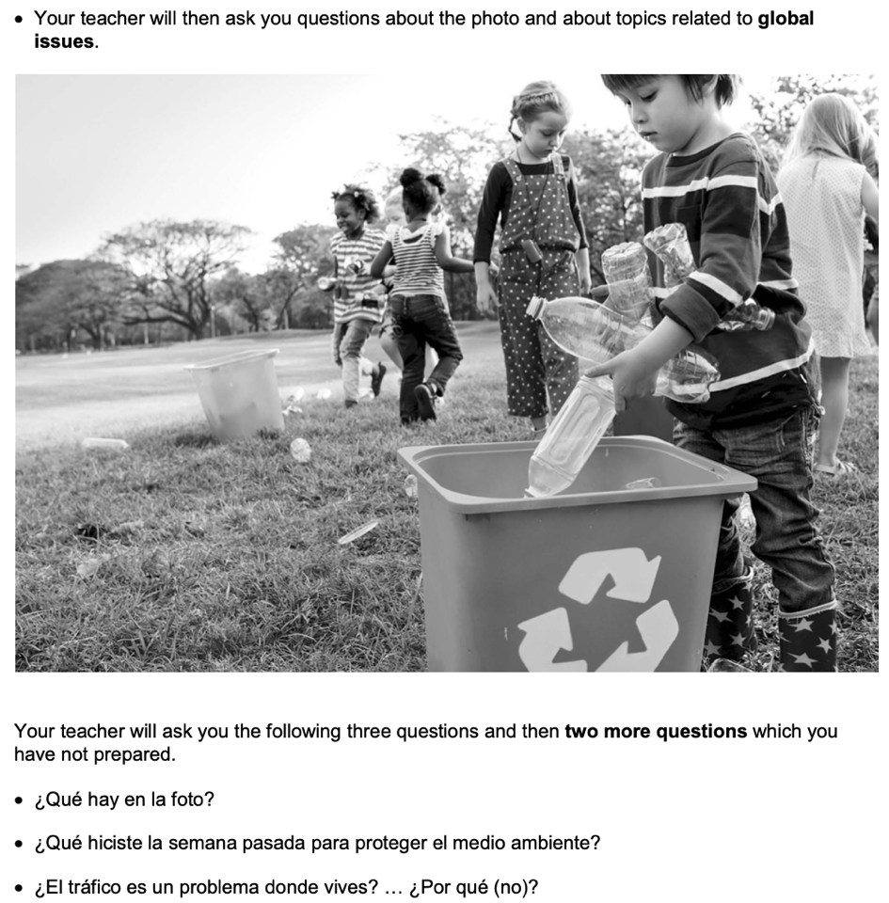
- PALMW the first question.

P ____________________________
____________________________
A ___________________________
___________________________
L ____________________________
____________________________
M ___________________________
___________________________
W ___________________________
___________________________

- Draft a response to question 2 in Spanish using 3 sentences.
____________________________________________________________________________________ ____________________________________________________________________________________
____________________________________________________________________________________
- Draft a response to question 3 in Spanish using an opinion + justification + 1 more sentence.
____________________________________________________________________________________ ____________________________________________________________________________________
____________________________________________________________________________________
- Prepare an answer to this using 1 sentence.
¿Qué cambios te gustaría ver para mejorar el transporte público en tu región?
____________________________________________________________________________________
- Prepare an answer to this using 1 sentence.
¿Cuál es tu opinión sobre proteger el medio ambiente? ... ¿Por qué?
____________________________________________________________________________________________

