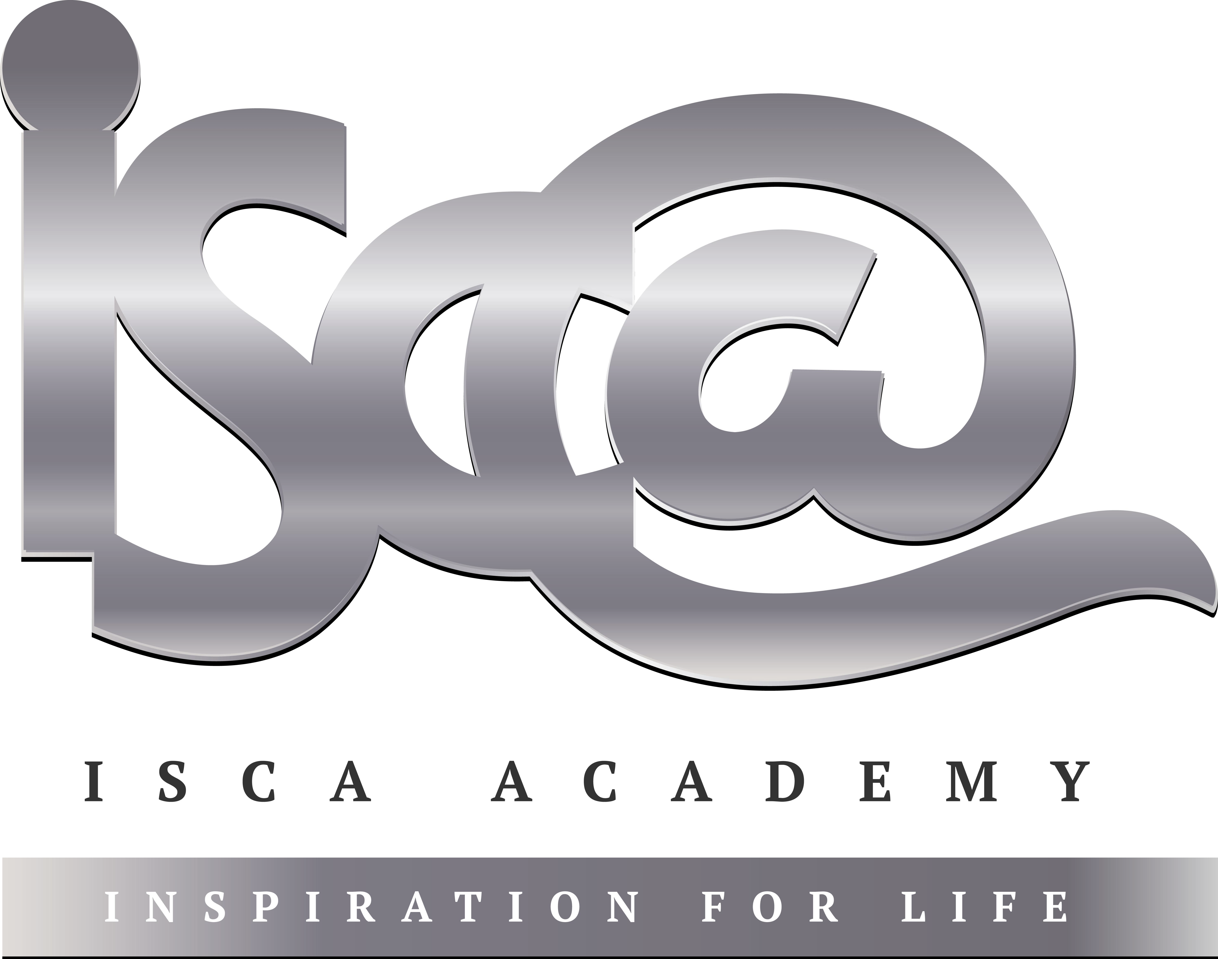
Year 11 Homework
Subject | History
Cycle | 1 | Week | 7
Hand in Date

Step 1: Complete the Week 7 Seneca quiz (class code: cx76l0q9h8) – If you don’t yet have a login please speak to your History teacher. Tick the box below to show that you’ve done it and enter the time you’ve spent on this week’s quiz.

Seneca complete Time spent:____________________

Step 2: Complete the tasks below:

- Label what you can see in the source below.
- Finish the sentence: ‘From this source I can infer that people in the Medieval people believed__________
____________________________________________________________________________________________________________________________________________________________________________________________________________________________________________________________________________________
__________________________________________________________________________________________________________________________________________

