Year 11 Homework
Subject | Religious Education
Cycle | 1 | Week | 8
Hand in Date
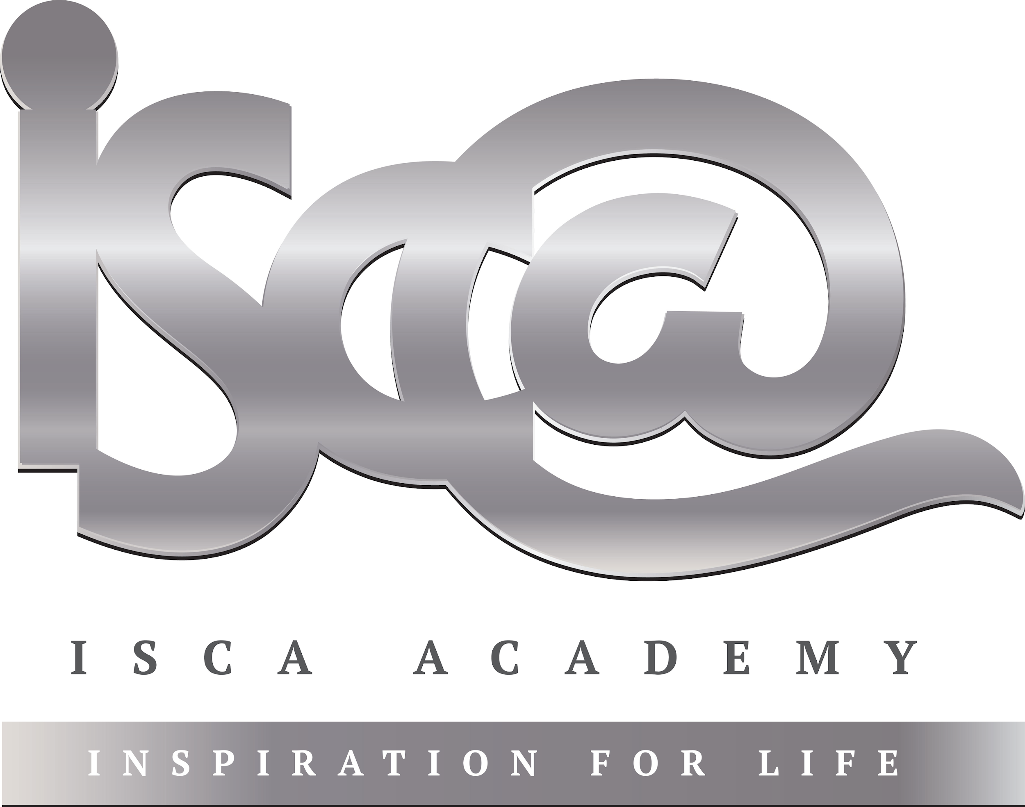
Recap of Themes:

Explain two contrasting religious opinions on the death penalty [5]

___________________________________________________________________________________________________________________________________________________________________________________________________________________________________________________________________________________________________________________________________________________________________________________________________________________________________________________

Explain two contrasting religious opinions on social justice [5]

___________________________________________________________________________________________________________________________________________________________________________________________________________________________________________________________________________________________________________________________________________________________________________________________________________________________________________________

Mock Revision:
Christianity (Beliefs and Practices)

- Nature of God (omnipotent, omnibenevolent, omniscient, trinity)
- The Afterlife
- Life of Jesus (Incarnation, miracles, crucifixion, resurrection, ascension)
- Prayer / Types of Prayer
- Role of the Church in the local community (food banks, street pastors)
- Lourdes and Iona

Revise these topics for your Christianity mock paper.
This can be done through creating revision cards, mind maps, rewriting information out etc.

